**FILE SHARING**

**PROFORMA FOR THE APPROVAL PROJECT PROPOSAL**

PNR **No.: 2019016400859103** Roll no**: 22**

**Name of the Student:** SHREYA JAIN

**Title of the Project:** FILE SHARING

**Name of the Guide:** MR. SAGAR MEHTA

**Teaching experience of the Guide:** 6 YEARS

Is this your first submission? Yes No

Signature of the Student Signature of the Guide

Date: ………………… Date: …………………….

Signature of the Coordinator Date: …………………

**FILE SHARING**

**A Project Report**

Submitted in partial fulfillment of the requirements for the award of the Degree of

**BACHELOR OF SCIENCE**

**By**

Shreya Jain

22

**Under the esteemed guidance of**

**Ms. Pragati Thawani**

##### Designation



**DEPARTMENT OF INFORMATION TECHNOLOGY**

**KISHINCHAND CHELLARAM COLLEGE**

***(Affiliated to University of Mumbai)***

**MUMBAI,400020**

**MAHARASHTRA**

**2021-22**

**KISHINCHAND CHELLARAM COLLEGE**

***(Affiliated to University of Mumbai)***

**MUMBAI-MAHARASHTRA-400020**

**DEPARTMENT OF INFORMATION TECHNOLOGY**



**CERTIFICATE**

This is to certify that the project entitled, **"File Sharing "**, is bonafide work of **Shreya Jain** bearing Seat. No: (**22**) submitted in partial fulfillment of the requirements for the award of the degree of BACHELOR OF SCIENCE in INFORMATION TECHNOLOGY from the University of Mumbai.

**Internal Guide Coordinator**

**External Examiner**

**Date:**

**Abstract**

File sharing is the oldest application of the internet. File sharing is the practice of sharing or offering access to digital information or resources, including documents, multimedia (audio/video), graphics, computer programs, images and e-books. It is the private or public distribution of data or resources in a network with different levels of sharing privileges. File sharing allows a number of people to use the same file or file by some combination of being able to read or view it, write to or modify it, copy it, or print it.

“V Share” is a file sharing website where users can share files to an individual or they can create groups for the same. Every user has to create an account on this website. If the user wants to share a file to an individual he/she has to send a request first in order to confirm the identity of the user. Once the request has been accepted they can start sharing the files. Users can also create the groups if they want to share the file to multiple people at the same time. Every group will have an admin and a coordinator. The person who will create group will directly become an admin and have certain privileges such as accepting the request of the user to join in that group, approving the request of the group member to share a file within a group, he/she can also decide whether there will be a coordinator or not and if yes who it should be. If a group has a coordinator then he also has the right to approve the request of the group member to share a file within a group in absence of the admin. There will also be a panel in which the users can chat.

**ACKNOWLEDGEMENT**

I would like to express my special thanks of gratitude to our dear principal **Dr. (Ms.) Hemlata K Bagla**, our Coordinator of B.Sc. (I.T) **Dr. Rakhi Gupta**, as well as our professor **Ms. Pragati Thawani,** gave me the golden opportunity to do this wonderful project on the topic “**File Sharing”**, also helped me in doing a lot of research and I came to know about so many new things. I am thankful to them.

I am grateful to all my friends and colleagues for their constant encouragement and support for assisting with their inputs.

**DECLARATION**

I hereby declare that the project entitled, “**File Sharing**” done at place where the project is done, has not been in any case duplicated to submit to any other university for the award of any degree. To the best of my knowledge other than me, no one has submitted to any other university. The project is done in partial fulfillment of the requirements for the award of degree of **BACHELOR OF SCIENCE (INFORMATION TECHNOLOGY)** to be submitted as final semester project as part of our curriculum.

**Name and Signature of the Student**

**FILE SHARING**

**TABLE OF CONTENTS**

|  |  |  |
| --- | --- | --- |
| **Chapter number** | **Content** | **Page no.** |
| **Chapter 1** | **Introduction** | 12-14 |
| 1.1 | Background | 12 |
| 1.2 | Objectives | 12 |
| 1.3 | Purpose Scope and Applicability | 12 |
| 1.3.1 | Purpose | 12 |
| 1.3.2 | Scope | 13 |
| 1.3.3 | Applicability | 13 |
| 1.4 | Achievements | 13 |
| 1.5 | Organization of Report | 13-14 |
| **Chapter 2** | **Survey of technology** | 16-21 |
| 2.1 | Features of Frontend | 16-19 |
| 2.1.1 | HTML | 16 |
| 2.1.2 | CSS3 | 17 |
| 2.1.3 | BOOTSTRAP | 17 |
| 2.1.4 | JAVASCRIPT & JQUERY | 18-19 |
| 2.2 | Features of Backend | 20 |
| 2.2.1 | PHP | 20 |
| 2.2.2 | MYSQL | 20 |
| 2.3 | Justification of selection of Technology | 21 |
| **Chapter 3** | **Requirements and Analysis** | 23-26 |
| 3.1 | Problem definition | 23 |
| 3.2 | Requirement Specification | 23 |
| 3.3 | Planning & Scheduling | 24 |
| 3.3.1 | Gantt chart | 24 |
| 3.4 | Software & Hardware requirements | 25 |
| 3.5 | Conceptual Models | 25 |
| 3.5.1 | Data Flow Diagram | 25-26 |
| **Chapter 4** | **System Design** | 28-49 |
| 4.1 | Data Design | 28-31 |
| 4.1.1 | Schema Design | 28 |
| 4.1.2 | Data Dictionary | 29-31 |
| 4.2 | Data Flow Diagram | 32-33 |
| 4.3 | Entity Relationship Diagram | 34-36 |
| 4.4 | Use Case Diagram | 37-38 |
| 4.5 | Class Diagram | 39-40 |
| 4.6 | Sequence Diagram | 41-44 |
| 4.7 | Activity Diagram | 45-49 |
| **Chapter 5** | **Implementation and Testing** | 51-53 |
| 5.1 | Implementation Approaches | 51 |
| 5.2 | Testing Approach | 51-52 |
| 5.2.1 | Unit Testing | 51 |
| 5.2.2 | Integration Testing | 52 |
| 5.2.3 | System Testing | 52 |
| 5.3 | Test Cases | 53 |
| **Chapter 6** | **User Documentation** | 55-71 |
| **Chapter 7** | **Cost and Benefit Analysis** | 73 |
| **Chapter 8** | **Conclusion** | 75 |
| **8.1** | Conclusion | 75 |
| **8.1.1** | Significance of the System | 75 |
| **8.2** | Limitations of the System | 75 |
| **8.3** | Future Scope of the Project | 75 |
| **Annexure** | **Annexure** | 76 |
| **Bibliography** | **Bibliography** | 77 |

**List of Diagrams**

|  |  |
| --- | --- |
| **Name** | **Page no.** |
| Data Flow Diagram | 33 |
| Entity Relationship diagram | 36 |
| Use case Diagram | 38 |
| Class Diagram | 40 |
| Sequence Diagram | 44 |
| Activity Diagram | 48-49 |

**List of Tables**

|  |  |
| --- | --- |
| Name | Page no. |
| Planning and Scheduling | 24 |
| Schema Design | 28 |
| Data Dictionary | 29-31 |

**Chapter 1**

**Introduction**

## 

**1.1 BACKGROUND**

* File sharing is the oldest application on the internet.
* File sharing is the practice of sharing or offering access to digital information or resources, including documents, multimedia (audio/video), graphics, computer programs, images, and e-books.
* It is the private or public distribution of data or resources in a network with different levels of sharing privileges.
* File sharing allows several people to use the same file or file by some combination of reading or viewing it, writing to or modifying it, copying it, or printing it.
* While sharing a file we sometimes face an issue of file size, to overcome this problem we are making a project based on file sharing, where we can share large-size files.

**1.2 OBJECTIVE**

* We are trying to make a user-friendly platform.
* People from all professions can use it.
* Nowadays size of the file has become an important factor and people face lots of problems for sharing huge-sized files, so using this website we are trying to make it easy and effective for the users to share files of any size they want.
* We can keep track of what file is been shared and by whom.

**1.3 PURPOSE, SCOPE, AND APPLICABILITY**

**1.3.1 Purpose**

* Nowadays people tend to share files online instead of using a pen-drive or other devices.
* Sharing file online is quite easy and can be done quickly, so the purpose of creating this project is to share files with a large size easily.
* It will be a user-friendly interface.

**1.3.2 Scope**

Since this is a website, you can share the file from anywhere and at any time. The project scope includes facilities for users to upload files online and can download files.

**1.3.3 Applicability**

* It is applicable for large as well as small organizations where the file needs to be shared.
* It is also applicable in the educational field in which students, teachers, and administrators can share files with ease.
* People of all age groups can use this platform to upload files.

**1.4 ACHIEVEMENTS**

* The result of this project is to let users share files irrespective of their type and size.
* It is a user-friendly system.
* It will provide features such as showing the history of downloaded and uploaded files.
* It also gives the user an option to either share files individually or in a group.

**1.5 ORGANISATION OF REPORT**

* Chapter 2 will summarize the details of the technologies that are necessary to complete the project.
* In chapter 3 problem statement will be defined which will be divided into subproblems. Requirement specifications will describe the things in the system and the actions that can be done on these things. In the planning and scheduling, Gantt chart and PERT will be made, also the hardware and software specifications will be defined. Conceptual Models will also be made.
* Chapter 4 describes desired features and operations in detail including screen layout, business rules, process diagrams, and other documentation
* Basic Modules: The students should follow the divide and conquer theory, so divide the overall problem into more manageable parts and develop each part or module separately.
* Data Design: Data design will consist of how data is organized, managed, and manipulated.
* Logic Diagrams: Define the systematical flow of the procedure that improves its comprehension and helps the programmer during implementation. e.g., Control Flow Chart, Process Diagrams, etc.
* We will also write about User -interface design, Security issues, Test cases design.
* Chapter 5 describes different types of testing like unit, integration, system testing, etc.
* Chapter 6 describes the User documentation which includes all screenshots of the project
* Chapter 7 describes cost and benefit analysis
* Chapter 8 describes significance of the system, limitations of the system and also future enhancement.

**Chapter 2**

**Survey of Technologies**

The Technologies used in the project are:

HTML5

CSS3

BOOTSTRAP

JAVASCRIPT

JQUERY

PHP

**2.1 FEATURES OF FRONTEND**

**2.1.1 HTML**

HTML stands for HyperText Markup Language. It is used to design web pages. Hypertext defines the link between the web pages. A markup language is used to define the text document within tag which defines the structure of web pages. HTML5 is designed, as much as possible, to be backward compatible with existing web browsers. Its new features have been built on existing features and allow you to provide fallback content for older browsers.

Features of HTML5:

* New Semantic Elements − These are like <header>, <footer>, and <section>.
* Forms 2.0 − Improvements to HTML web forms where new attributes have been introduced for <input> tag.
* Easy character encoding i.e., <meta charset=” UTF-8”>
* There are new graphics elements including vector graphics and tags.
* JAVASCRIPT can run in the background, thanks to HTML5.
* Easy to create a new interactive website.

**2.1.2 CSS3**

CSS3 is used for styling purposes. When you want to edit the design on your website, changing a few lines of CSS is much easier and less time-consuming. Resizing an element, changing the border-radius, changing colors and gradients, are all things that take a few seconds to change in CSS.

1. **Box Shadows:** You’ll usually find this effect used subtly to surround item containers on a webpage. With CSS3, you can now easily create a shadow around an element with some code and .
2. Rounded Corners:Rounded corners just look more user-friendly than square boxes. You can apply this effect to HTML elements with CSS3.
3. **Text Shadows:** You can add a shadow to HTML text that can then be highlighted, copied, and pasted just like normal text.  You can change the shadow angle, the shadow blur, and the shadow color in CSS.
4. **Opacity:** This property makes can make elements more see-through.

**2.1.3 BOOTSTRAP**

BOOTSTRAP is an open-source and free CSS framework, which helps in directing a responsive device-friendly mobile-first front-end web page development tool. Bootstrap includes the CSS.It provides a clean and uniform solution for building an interface for developers. It contains beautiful and functional built-in components which are easy to customize. It also provides web-based customization.And best of all it is open-source.

1. Browser supportive: Every browser supports this Bootstrap Framework.
2. Simple and easy to start: If you know HTML and CSS, you can quickly start working with Bootstrap, and its documentation is provided on the official site.
3. Responsive design and looks: Web pages designed using the Bootstrap framework have responsive CSS that can adjust to the screen size of large desktops, notebooks, tablets, and mobiles.
4. Easy customization: It provides some built-in components and functionalities that are easy for customizing.
5. Clean interface or Developers: The bootstrap framework provides a new and consistent result for building user interfaces in web pages.
6. It is an open-source framework with web-based customization.

**2.1.4 JAVASCRIPT & JQUERY**

JavaScript is a major scripting programming language that is used to make websites more responsive and interactive. If HTML & CSS decorates and designed the web pages so, JavaScript makes the web pages dynamic. JavaScript is an independent language and can exist on its own. We can make animations in JavaScript.

 jQuery is a framework for JavaScript which developed from JavaScript. It is an open-source JavaScript library. The purpose of jQuery is to make life easier for the masses so that they can easily develop websites and browser-based applications using JavaScript.

The jQuery. Ajax(options) method loads a remote page using an HTTP request.

Syntax:

$. ajax ({name: value, name: value*, ...*})

The parameters specify one or more name/value pairs for the AJAX request.

Parameters

Here is the description of some of the parameters used by this method −

**options** − A set of key/value pairs that configure the Ajax request. All options are optional.

**data-**A map or string that is sent to the server with the request.

**success-**A callback function that is executed if the request succeeds.

**url-**A string containing the URL to which the request is sent.

**type-**A string defining the HTTP method to use for the request (GET or POST). The default value is GET.

The $. post () method loads data from the server using an HTTP POST request.

Syntax:

$. post (url, [data],[callback],[type])

Parameters

Here is the description of all the parameters used by this method −

**url** − A string containing the URL to which the request is sent

**data** − This optional parameter represents key/value pairs or the return value of the. serialize () function that will be sent to the server.

**callback** − This optional parameter represents a function to be executed whenever the data is loaded successfully.

**type** − This optional parameter represents a type of data to be returned to callback function: "xml", "html", "script", "json", "jsonp", or "text".

Features of JavaScript are:

* Light Weight Scripting language
* Dynamic Typing
* Object-oriented programming support
* Functional Style
* Platform Independent
* Interpreted Language
* Client-Side Validation

Features of jQuery are:

* Simple and easy
* Lightweight
* CSS manipulation
* Html manipulation
* Event handling
* JavaScript Library
* Built-in Animation

**2.2 FEATURES OF BACKEND**

**2.2.1 PHP**

The term PHP is an acronym for PHP: Hypertext Preprocessor. PHP is a server-side scripting language designed specifically for web development. It is open-source.

* PHP code is executed in the server.
* It can be integrated with many databases such as Oracle, Microsoft SQL Server, It, PostgreSQL, Sybase, Informix. (In this project Its database is used)
* One of the main reasons behind this is that PHP can be easily embedded in HTML files and HTML codes can also be written in a PHP file.
* The thing that differentiates PHP from the client-side language like HTML is, PHP codes are executed on the server whereas HTML codes are directly rendered on the browser. PHP codes are first executed on the server and then the result is returned to the browser.
* The only information that the client or browser knows is the result returned after executing the PHP script on the server and not the actual PHP codes present in the PHP file.

**2.2.2 MYSQL**

With PHP, you can connect to and manipulate databases. It is the most popular database system used with PHP. The data in a MySQL database are stored in tables. A table is a collection of related data, and it consists of columns and rows. Databases are useful for storing information categorically. It is a database system used on the web. It is a database system that runs on a server and is ideal for both small and large applications. It is very fast, reliable, and easy to use. It uses standard SQL. It compiles on several platforms. It is free to download and use. It is developed, distributed, and supported by Oracle Corporation.

**2.3 JUSTIFICATION OF SELECTION OF TECHNOLOGY**

**HTML5**

1. Users expect to access web applications from anywhere, anytime on any device.
2. HTML5 makes mobile support easier for smartphones and tablets.
3. Audio & Video − You can embed audio or video on your web pages without resorting to third-party plugins.
4. The form field autofocus attribute lets developers designate which form field will have input focus once the page loads.
5. Since it's now implied that script and link tags refer to scripts and style sheets respectively, the need for the type attribute has been eliminated.
6. HTML5 is being built to make things easier and more cross-browser-friendly.
7. Viewport: this allows you to define viewport widths and zoom settings.

**PHP**

1. PHP solution can work on various operating systems – Windows, Linux, Mac, Unix
2. This programming language provides compatibility with most servers
3. PHP is considered to be easy to learn
4. PHP works quickly and efficiently on a server-side in most cases
5. It supports different types of databases
6. PHP is an open-source framework and can be downloaded for free.
7. it can collect data, set, and receive cookies.
8. PHP gives the ability to change, update or delete data in the database, set user access to this data, and encrypt it.

**Chapter 3**

**Requirement and Analysis**

**3.1 PROBLEM DEFINITION**

* File sharing allows several people to use the same file or file by some combination of reading or viewing it, writing to or modifying it, copying it, or printing it.
* While sharing a file we sometimes face an issue of file size, to overcome this problem we are making a project based on file sharing, where we can share the file with a large file.
* Since this is a website, the user is not required to have a specific app

**3.2 REQUIREMENT SPECIFICATION**

* We are trying to make a user-friendly platform. Some users find it hard to operate a website as they cannot understand how to do a particular task, so we are trying to design a website in such a way so that the user will not face any difficulty while operating it.
* People from all professions can use it. As nowadays everything is digitalized and almost all professions tend to share files so this platform can be useful for them.
* File size is the main issue when it comes to sharing files, so by using this platform we can share large files.
* This platform will help in keeping the track of the files as with whom the file is been shared and who is sharing the file.

**3.3 PLANNING AND SCHEDULING**

|  |  |  |
| --- | --- | --- |
| Task | Start Date | End date |
| Search for topic | 22/06/2021 | 25/06/2021 |
| Submission of Topic | 27/06/2021 | 30/06/2021 |
| Topic Finalized | 06/07/2021 | 06/07/2021 |
| Survey of Technology | 07/07/2021 | 10/07/2021 |
| Requirement and Analysis | 14/07/2021 | 29/07/2021 |
| System Design | 10/08/2021 | 06/09/2021 |
| Coding | 08/09/2021 | 20/02/2022 |
| Implementation and Testing | 01/01/2022 | 20/02/2022 |
| Documentation | 20/07/2021 | 14/03/2022 |

**3.3.1 Gantt Chart:**

**3.4 SOFTWARE AND HARDWARE REQUIREMENT**

Software used:

1. VS code
2. Xampp 3.2.4 lowest version
3. Google Meet
4. Google Chrome-We are using version 92

Hardware used:

1. Windows operating system
2. Intel Processor used
3. Minimum i3 and maximum i5

**3.5 CONCEPTUAL MODELS**

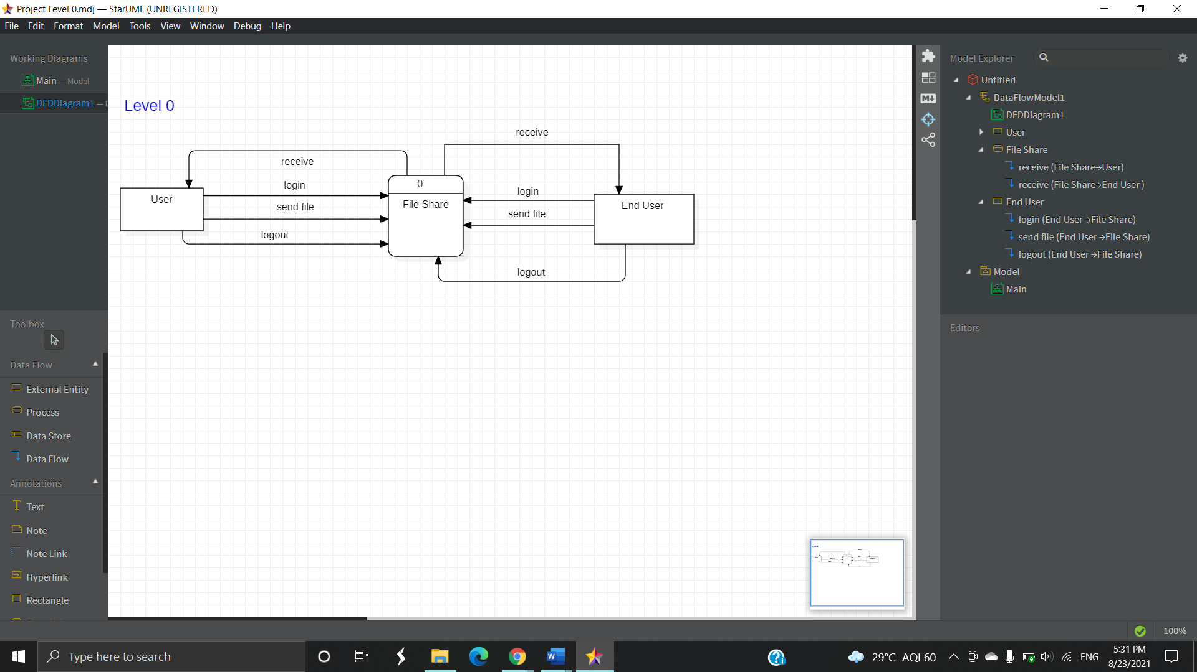**3.5.1 Data Flow diagrams:**

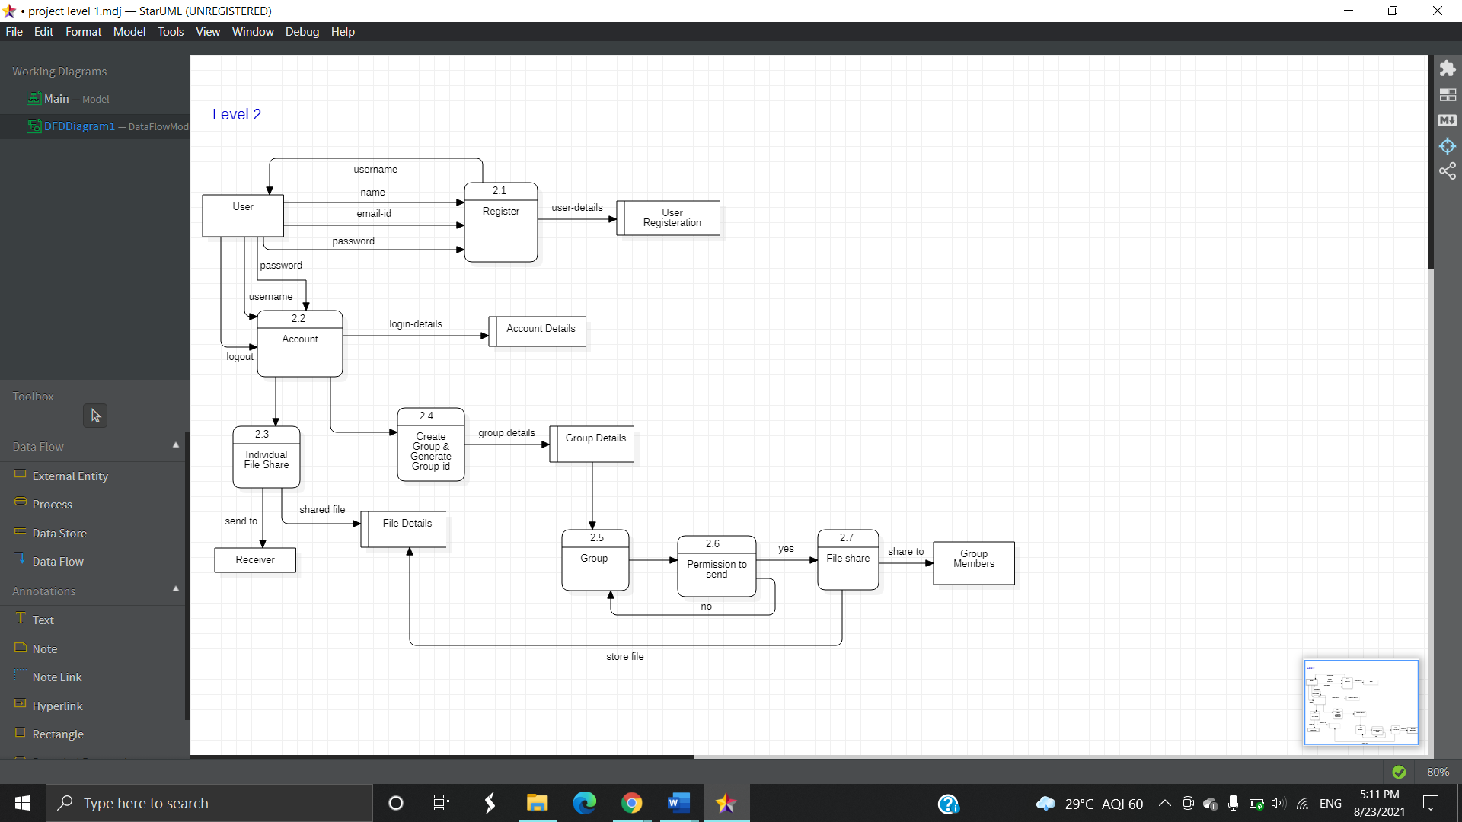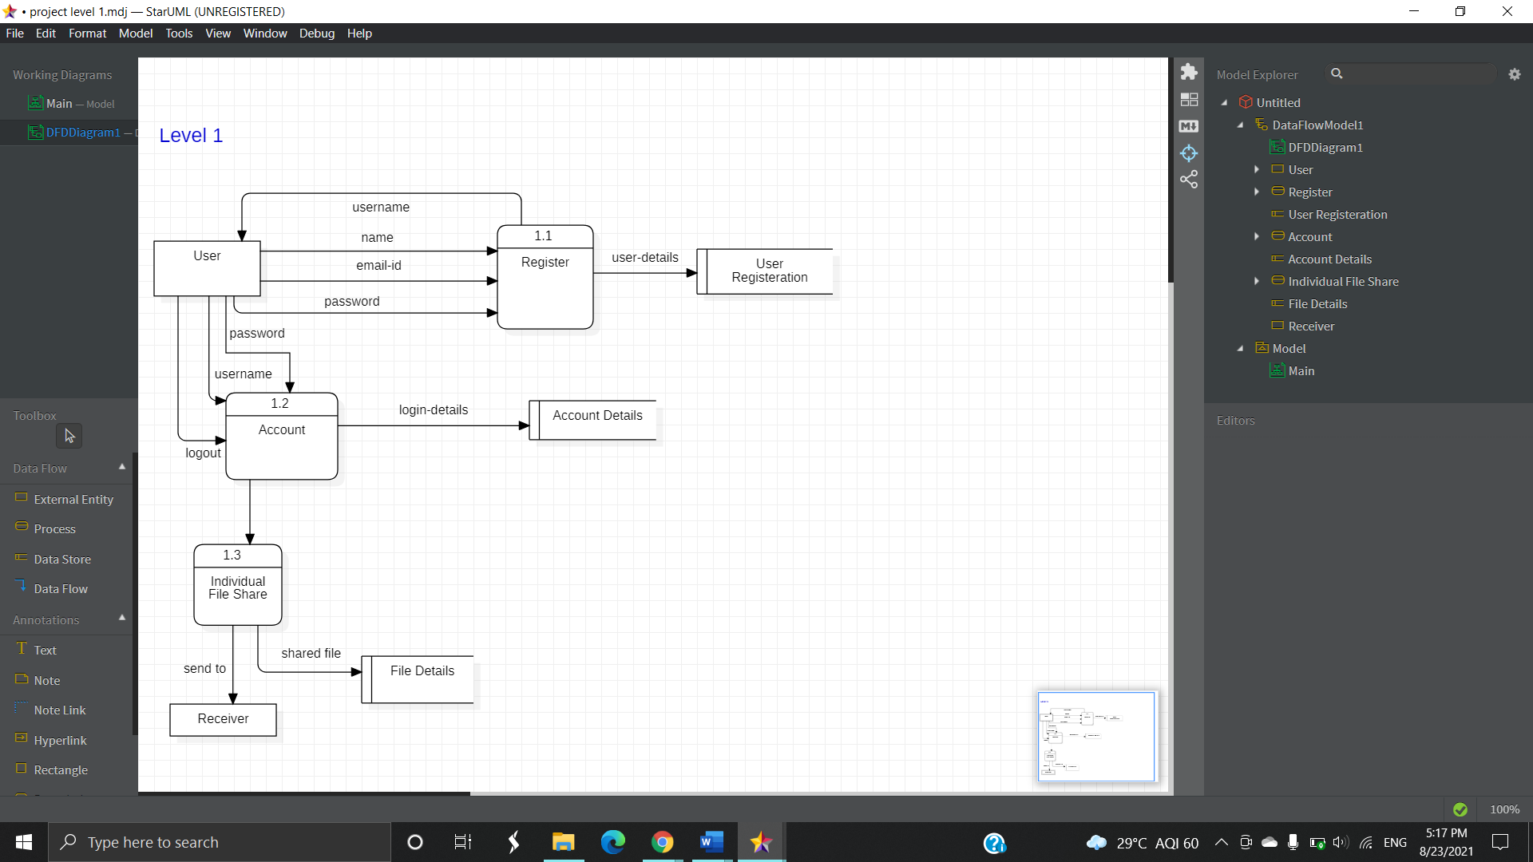

**Chapter 4**

**4.1 DATA DESIGN**

**4.1.1 Schema Design**

|  |  |  |
| --- | --- | --- |
| Table Name | Primary key field | Other fields |
| users | UserName | FullName, Email, UserPassword |
| Usergroups | id | UserName, GroupID, UserRole |
| individual | id | u_id, Sender, Receiver, stime, originalname,size, tmpname, filetype |
| groupnotify | srno | GroupID, UserName, AdminName, Permission, time, Permission_Time |
| fileup | id | UserName, room, stime, originalname,size, tmpname, filetype |
| downloadedfile | id | UserName, filename, GroupID, Sender |
| creategroup | GroupID | SRno,UserName,UserRole |
| adduser | id | UserName,Receiver |

**4.1.2 Data dictionary**

**users:**

|  |  |  |  |
| --- | --- | --- | --- |
| **Column** | **Datatype** | **Key** | **Description** |
| UserName | varchar (20) | Primary Key | Stores username of the user. |
| FullName | varchar (30) |  | Stores full name of the user |
| UserPassword | varchar (255) |  | Stores password  created by the user |
| Email | varchar (50) | Foreign Key | Will contain email id of the user |

**usergroups:**

|  |  |  |  |
| --- | --- | --- | --- |
| **Column** | **Datatype** | **Key** | **Description** |
| id | int (11) | Primary Key | Stores the unique id of the user |
| UserName | varchar (20) |  | Stores username of the user who entered the group |
| GroupID | varchar (20) | Foreign Key | Stores the group id in which the user is either a participant or admin |
| UserRole | varchar (20) |  | Specifies the role of the user in that particular group i.e either participant or admin |

**individual:**

|  |  |  |  |
| --- | --- | --- | --- |
| **Column** | **Datatype** | **Key** | **Description** |
| id | int (11) | Primary Key | Stores the unique id of the individual user |
| u_id | int (11) | Foreign Key | It refers to the users in adduser table |
| Sender | varchar (20) |  | Stores the name of sender |
| Receiver | varchar (20) |  | Stores the name of receiver |
| stime | datetime |  | Stores file upload time |
| originalname | varchar (255) |  | Name of the file |
| size | bigint (20) |  | Size of the file |
| tmpname | varchar (255) |  | Temporary name of the file |
| filetype | varchar (255) |  | Stores file type |

**groupnotify:**

|  |  |  |  |
| --- | --- | --- | --- |
| **Column** | **Datatype** | **Key** | **Description** |
| srno | int (11) | Primary Key | Unique id |
| UserName | varchar (20) |  | User sending the request |
| GroupID | varchar (20) |  | Group where user wants to share |
| AdminName | varchar (30) |  | Admin of the group |
| Permission | int (11) |  | Whether request is accepted or not |
| time | timestamp |  | When the request was sent |
| Permission_Time | timestamp |  | When the request was accepted |

**fileup:**

|  |  |  |  |
| --- | --- | --- | --- |
| **Column** | **Datatype** | **Key** | **Description** |
| id | int (11) | Primary Key | Unique id |
| UserName | varchar (20) |  | User sending the file |
| room | varchar (20) | Foreign Key | Group where user wants to share |
| stime | datetime |  | Stores file upload time |
| originalname | varchar (255) |  | Name of the file |
| size | bigint (20) |  | Size of the file |
| tmpname | varchar (255) |  | Temporary name of the file |
| filetype | varchar(255) |  | Stores file type |

**downloadedfile:**

|  |  |  |  |
| --- | --- | --- | --- |
| **Column** | **Datatype** | **Key** | **Description** |
| id | int (11) | Primary Key | Unique id |
| UserName | varchar (20) |  | User who downloaded the file |
| filename | varchar (255) |  | Files that are downloaded |
| GroupID | varchar (20) |  | Group where file is shared |
| Sender | varchar (20) |  | User from individual chat |

**creategroup:**

|  |  |  |  |
| --- | --- | --- | --- |
| **Column** | **Datatype** | **Key** | **Description** |
| SRno | int (11) | Foreign Key | Unique id |
| UserName | varchar (20) |  | Name of the user |
| UserRole | varchar (20) |  | Admin |
| GroupID | varchar (20) | Primary Key | Generated groupid |

**adduser:**

|  |  |  |  |
| --- | --- | --- | --- |
| **Column** | **Datatype** | **Key** | **Description** |
| id | int (11) | Primary Key | Unique id |
| UserName | varchar (20) |  | User who wants to start the chat |
| Receiver | varchar (20) |  | End user |

**Conceptual Models**

**4.2 Data Flow Diagrams**

* A data-flow diagram (DFD) is a graphical representation of the flow of data through a process or a system.
* A data flow diagram looks at how the data flows through a system.
* It shows the movement of data external entities and the processes and the data stored within the system.
* DFD is not a ‘flow chart’. The flow chart shows ‘flow of control’ whereas DFD shows the flow of data.
* The DFD is also called a data flow graph.

|  |  |  |
| --- | --- | --- |
| **Symbols** | **Name** | **Function** |
|  | Data Flow | Used to connect processes, to source/sink. The arrowhead indicated the direction of data flow. |
|  | Source / Sink  (External entity) | A source of system inputs, a sink of a system outputs. |
| #  Process | Process | It performs some transformation of input data to yield output data. |
| # | Data Store | It is a repository of data. It indicates the data that the system store. Two data stores cannot be connected with the data flow. |







**4.3 Entity-Relationship Diagram**

**ER Diagram** stands for Entity Relationship Diagram, also known as ERD is a diagram that displays the relationship of entity sets stored in a database. In other words, ER diagrams help to explain the logical structure of databases. ER diagrams are created based on three basic concepts: entities, attributes, and relationships.

Symbol Name Description

|  |  |  |  |  |
| --- | --- | --- | --- | --- |
| Strong Entity Symbol | | Strong entity | | These shapes are independent of other entities and are often called parent entities since they will often have weak entities that depend on them. They will also have a primary key, distinguishing each occurrence of the entity. |
| Weak Entity Symbol | | Weak entity | | Weak entities depend on some other entity type. They don't have primary keys and have no meaning in the diagram without their parent entity. |
| Relationship Symbol | | Relationship | | Relationships are associations between or among entities. |
| Weak Relationship Symbol | | Weak relationship | | Weak Relationships are connections between a weak entity and its owner. |
| Attribute Symbol | | Attribute | | Attributes are characteristics of an entity, a many-to-many relationship, or a one-to-one relationship. |
| Multivalued Attribute Symbol | | Multivalued  Attribute | | Multivalued attributes are those that are can take on more than one value. |
|  | |  |  |

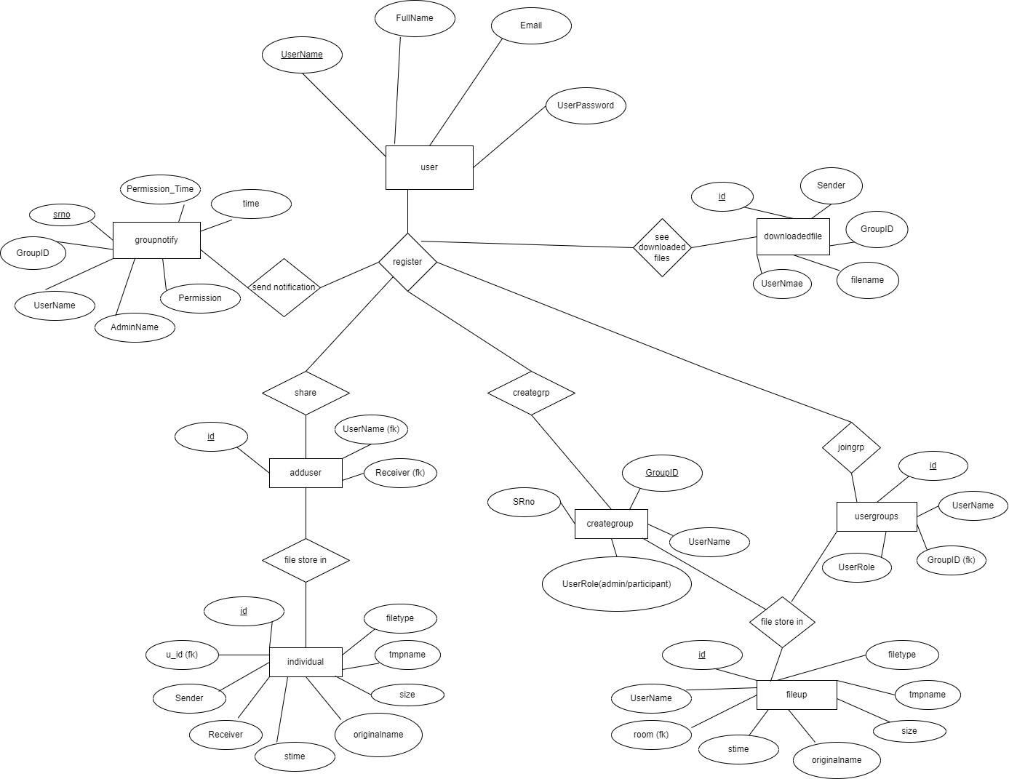

**4.4 Use Case Diagram**

**Use Case Diagram** captures the system's functionality and requirements by using actors and use cases. Use Cases model the services, tasks, function that a system needs to perform. Use cases represent high-level functionalities and how a user will handle the system.

**Use Case Diagram Notations**

1. Use Case

Use cases are used to represent high-level functionalities and how the user will handle the system. A use case represents a distinct functionality of a system, a component, a package, or a class. It is denoted by an oval shape with the name of a use case written inside the oval shape. The notation of a use case in UML is given below:

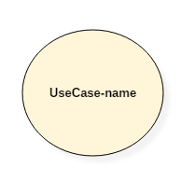

2. Actor:

It is used inside use case diagrams. The actor is an entity that interacts with the system. A user is the best example of an actor. An actor is an entity that initiates the use case from outside the scope of a use case. It can be any element that can trigger an interaction with the use case. One actor can be associated with multiple use cases in the system. The actor notation in UML is given below.

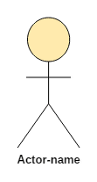

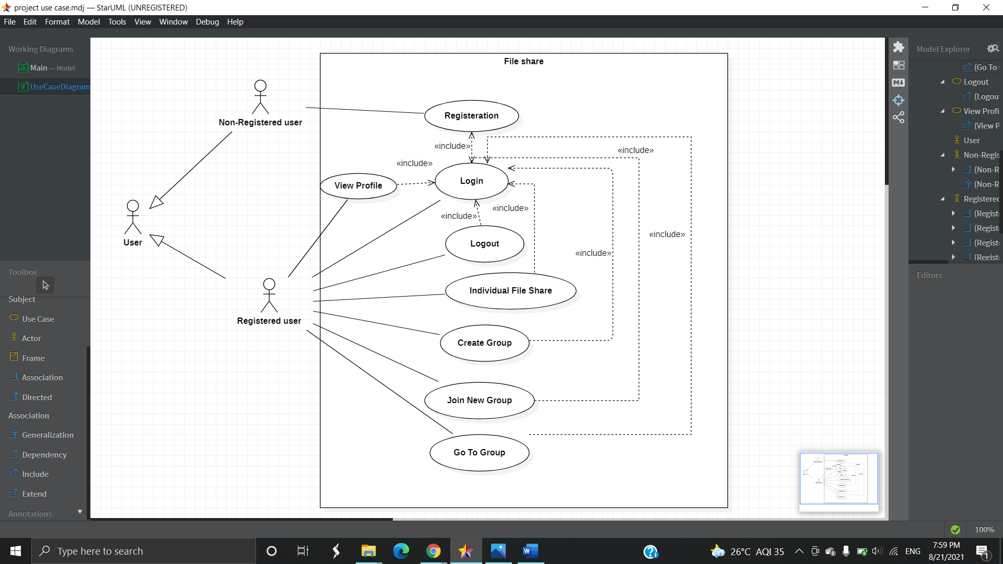

**4.5 Class Diagram**

* Class diagram describes the attributes and operations of a class and

also, the constraints imposed on the system.

* Class diagram shows a collection of classes, interfaces, associations,

collaborations, and constraints.

Class Name

attribute

operations

Relationships:

* Generalization

1. It connects a subclass to its superclass.
2. Denotes an inheritance of attributes and behavior from superclass to subclass

* Association:

1. If two classes in a model need to communicate with each other there must be a link between them
2. An association denotes that link

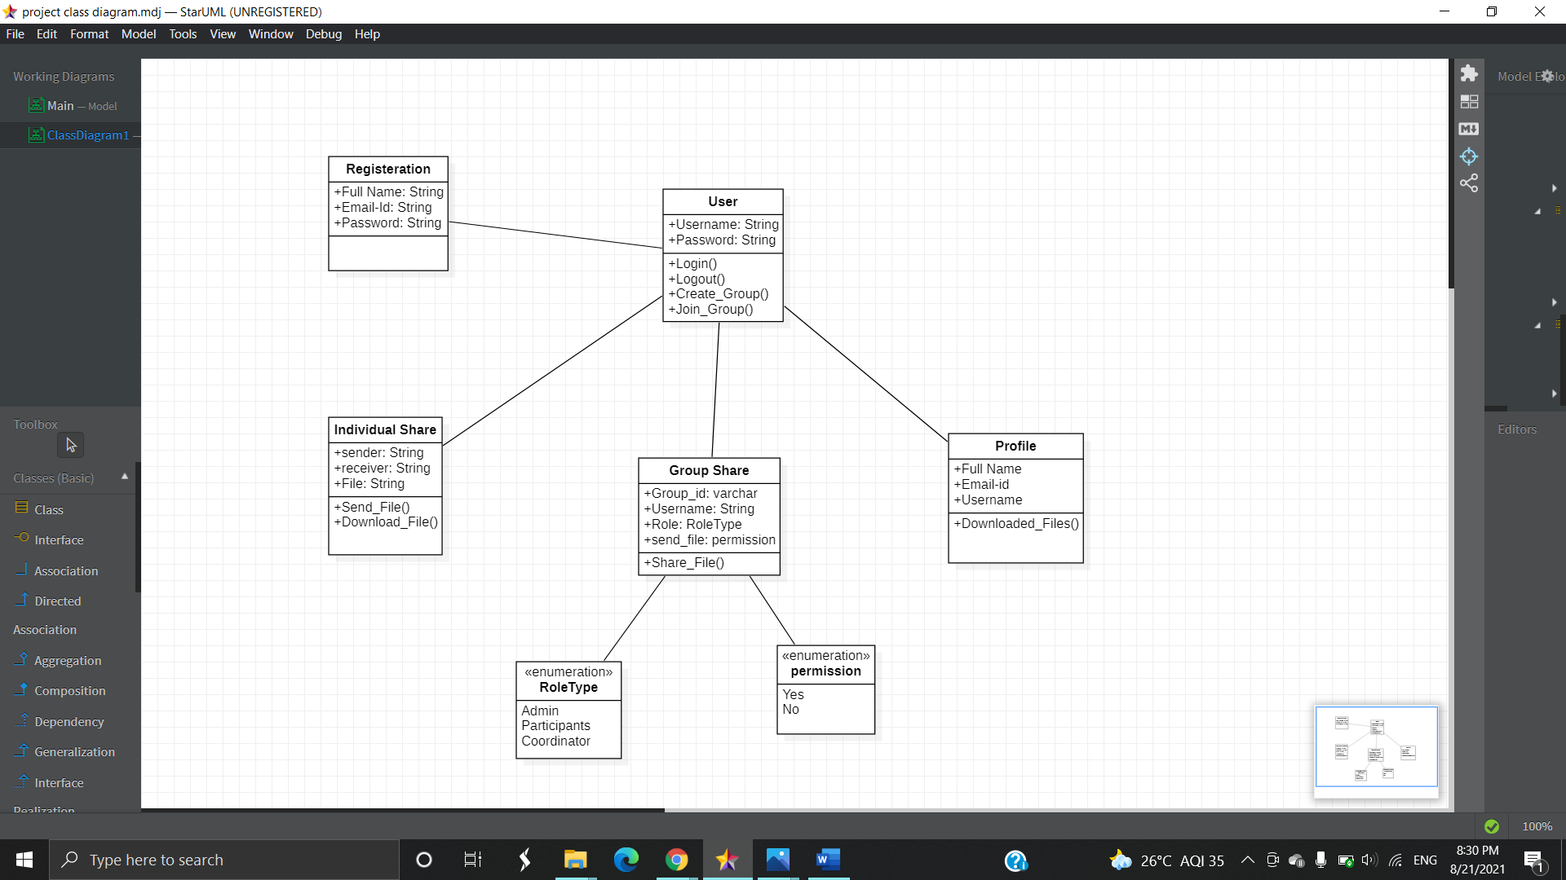

**4.6 Sequence Diagram**

* A sequence diagram is a type of interaction diagram because it describes how—and in what order—a group of objects works together. Sequence diagrams are sometimes known as event diagrams or event scenarios. It sees how objects and components interact with each other to complete a process.

1. Lifeline Notation:

A sequence diagram is made up of several of these lifeline notations that should be arranged horizontally across the top of the diagram. No two lifeline notations should overlap each other. They represent the different objects or parts that interact with each other in the system during the sequence.

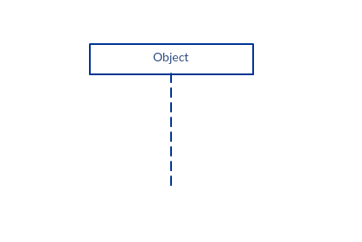

1. Activation Bars:

The activation bar is the box placed on the lifeline.  It is used to indicate that an object is active (or instantiated) during an interaction between two objects. The length of the rectangle indicates the duration of the objects staying active. In a sequence diagram, an interaction between two objects occurs when one object sends a message to another. The use of the activation bar on the lifelines of the Message Caller (the object that sends the message) and the Message Receiver (the object that receives the message) indicates that both are active/are instantiated during the exchange of the message.

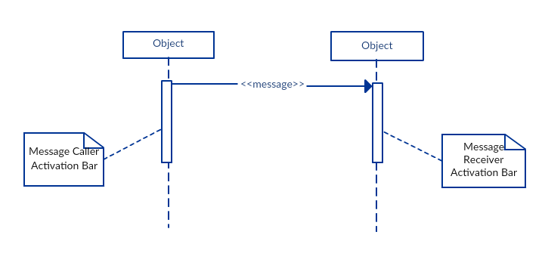

3. Message Arrows

An arrow from the Message Caller to the Message Receiver specifies a message in a sequence diagram.   A message can flow in any direction; from left to right, right to left, or back to the Message Caller itself. While you can describe the message being sent from one object to the other on the arrow, with different arrowheads you can indicate the type of message being sent or received. The message arrow comes with a description, which is known as a message signature, on it.

* Synchronous message

A synchronous message is used when the sender waits for the receiver to process the message and return before carrying on with another message.  The arrowhead used to indicate this type of message is a solid one, like the one below.

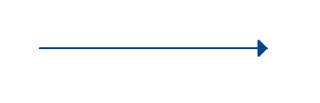

* Return message

A return message is used to indicate that the message receiver is done processing the message and is returning control over to the message caller. Return messages are optional notation pieces, for an activation bar that is triggered by a synchronous message always implies a return message.  
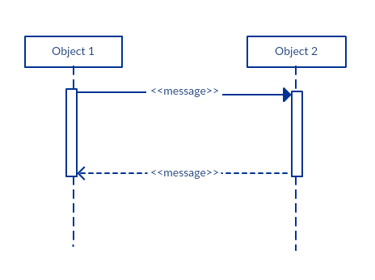

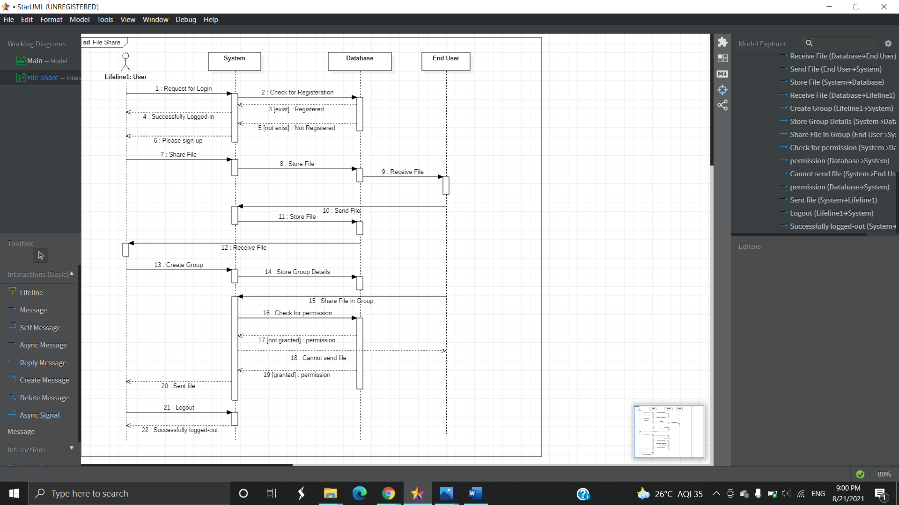

**4.7 Activity Diagram**

An activity diagram visually presents a series of actions or flow of control in a system similar to a [flowchart](https://www.smartdraw.com/flowchart/) or a [data flow diagram](https://www.smartdraw.com/data-flow-diagram/). Activity diagrams are often used in business process modeling. They can also describe the steps in a [use case diagram](https://www.smartdraw.com/use-case-diagram/). In both cases, an activity diagram will have a beginning (an initial state) and an end (a final state).

1. Initial State or Start Point

A small filled circle followed by an arrow represents the initial action state or the start point for any activity diagram. For the activity diagram using swimlanes, make sure the start point is placed in the top left corner of the first column.



2. Activity or Action State

An action state represents the non-interruptible action of objects. You can draw an action state using a rectangle with rounded corners.

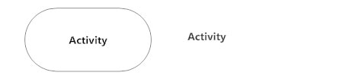

3. Action Flow

The action flows, also called edges and paths, illustrate the transitions from one action state to another. They are usually drawn with an arrowed line.

4. Decisions and Branching

A diamond represents a decision with alternate paths. When an activity requires a decision before moving on to the next activity, add a diamond between the two activities. The outgoing alternates should be labeled with a condition or guard expression. You can also label one of the paths "else."

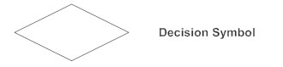

5. Guards

In UML, guards are a statement written next to a decision diamond that must be true before moving next to the next activity. These are not essential but are useful when a specific answer, such as "Yes, three labels are printed," is needed before moving forward.

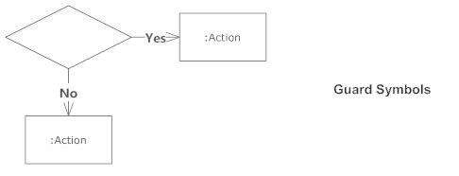

6. Swimlanes:

Swimlanes group related activities into one column.

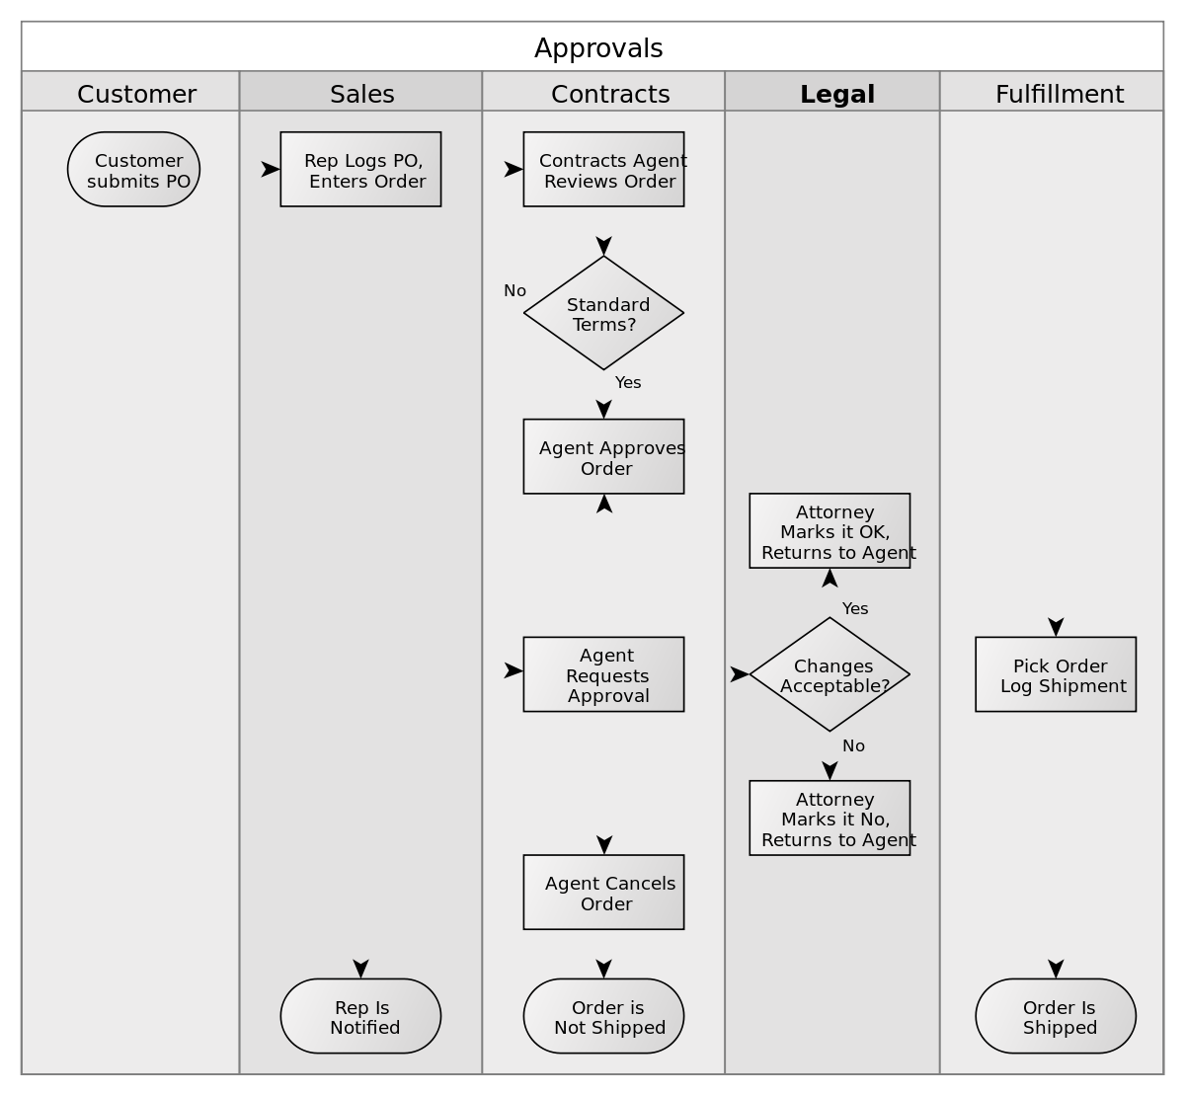

7. Final State or End Point

An arrow pointing to a filled circle nested inside another circle represents the final action state.



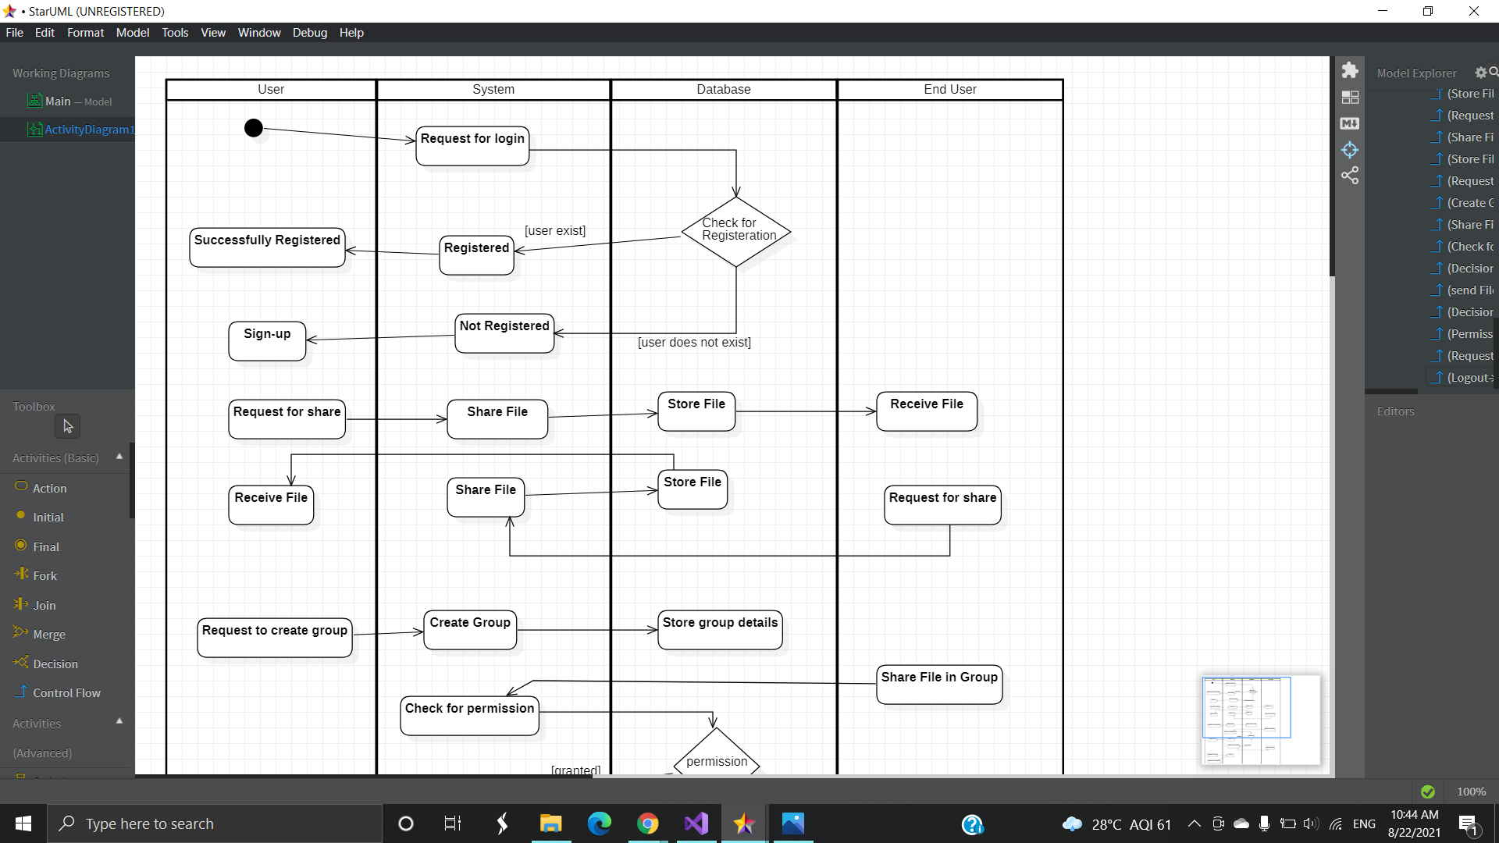

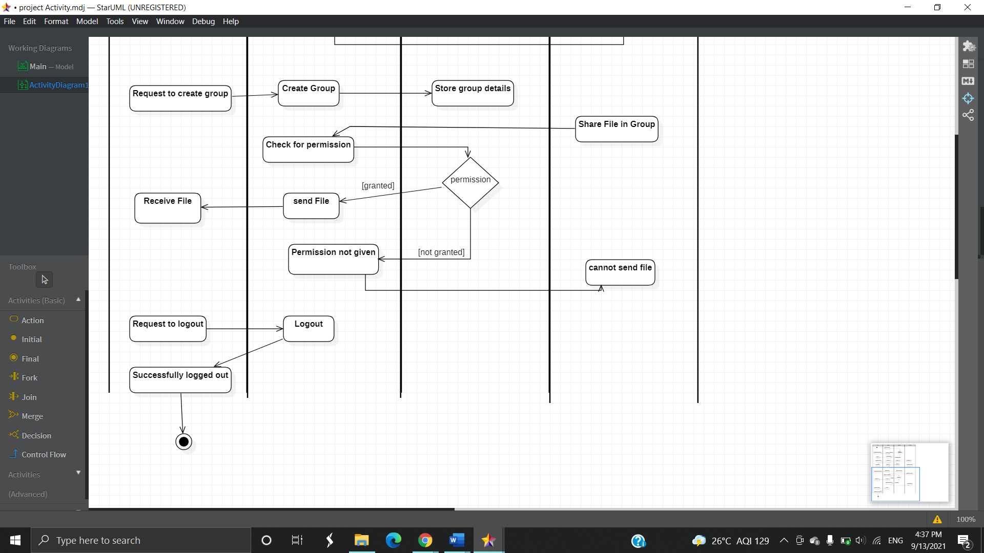

**Chapter 5**

**5.1 IMPLEMENTATION APPROACHES**

* A planned approach for a successful project is of utmost importance as the saying goes like
* "Plans are of little importance, but planning is essential."
* The planning approach used in this project is AGILE METHODOLOGY

AGILE METHODOLOGY

* Agile is a methodology of early delivering business value with less bureaucracy.
* It is a collection of software development methodology which works on an iterative and incremental method building the software from the very initiation of the project development instead of building all the software at once
* Agile discovers what the customer wants and how to build the code and change things along the way.
* Agile works by breaking down the project into smaller chunks and then continuously delivering them in short two weeks’ cycles called iterations.
* In an agile development process, solutions are obtained by self-organizing teams which collaborate, discuss, and constantly strive to improve their working process and become more effective in what they do.

**5.2 TESTING APPROACH**

**5.2.1 UNIT TESTING**

* Unit testing, a testing technique using which individual modules are tested to determine if there are any issues by the developer himself.
* It is concerned with functional correctness of the standalone modules.
* The main aim is to isolate each unit of the system to identify, analyze and fix the defects.

**BLACK-BOX TESTING**

* The technique of testing without having any knowledge of the interior workings of the application is called black-box testing.
* The tester is oblivious to the system architecture and does not have access to the source code.
* Typically, while performing a black-box test, a tester will interact with the system by providing inputs and examining outputs without knowing how and where the inputs are worked upon.

**WHITE-BOX TESTING**

* White-box testing is the detailed investigation of internal logic and structure of the
* code. White-box testing is also called glass testing or open-box testing.
* In order to perform white-box testing on a component, a tester needs to know the internal workings of the code.
* The tester needs to have a look inside the source code and find out which unit/chunk of the code is behaving inappropriately.

**5.2.2 INTEGRATION TESTING**

* Upon completion of unit testing, the units or modules are to be integrated which gives raise to integration testing.
* The purpose of integration testing is to verify the functional, performance, and reliability between the modules that are integrated.

**5.2.3 SYSTEM TESTING**

* **System Testing** is a level of testing that validates the complete and fully integrated software product.
* The purpose of a system test is to evaluate the end-to-end system specifications.
* Testing the fully integrated applications including external peripherals in order to check how components interact with one another and with the system as a whole.

**5.3 TEST CASES:**

|  |  |  |  |  |  |
| --- | --- | --- | --- | --- | --- |
| No. | Test condition | Procedure | Input | Expected Output | Obtained Output |
| 1. | To check registration form | To check if blank values are allowed | Full name:<empty> Email:<empty>  Password:<empty> | Error message should be displayed | Please fill out this field |
|  |  | To check for duplication of data | Enter already existing data | Error message should be displayed | Email already exists |
|  |  | To check for correct password pattern | Enter incorrect pattern | Error  message  should be  displayed | Please match the pattern |
| 2. | To check login form | To check if blank values are allowed | Username:<empty>  Password:<empty> | Error message should be displayed | Please fill out this field |
|  |  | To check for successful validation | Enter invalid username password | Error message should be displayed | Invalid credentials |
|  |  | To check for valid data | Enter valid data | Successfully redirects | Redirects accordingly |
| 3. | To join groups | To check for incorrect groupid | Enter invalid groupid | Error message should be displayed | No such group exists |
|  |  | To check for valid group | Enter valid groupid | Successfully entered into group | Redirects accordingly |

**Chapter 6**

**User Documentation**

**Registration Page:**

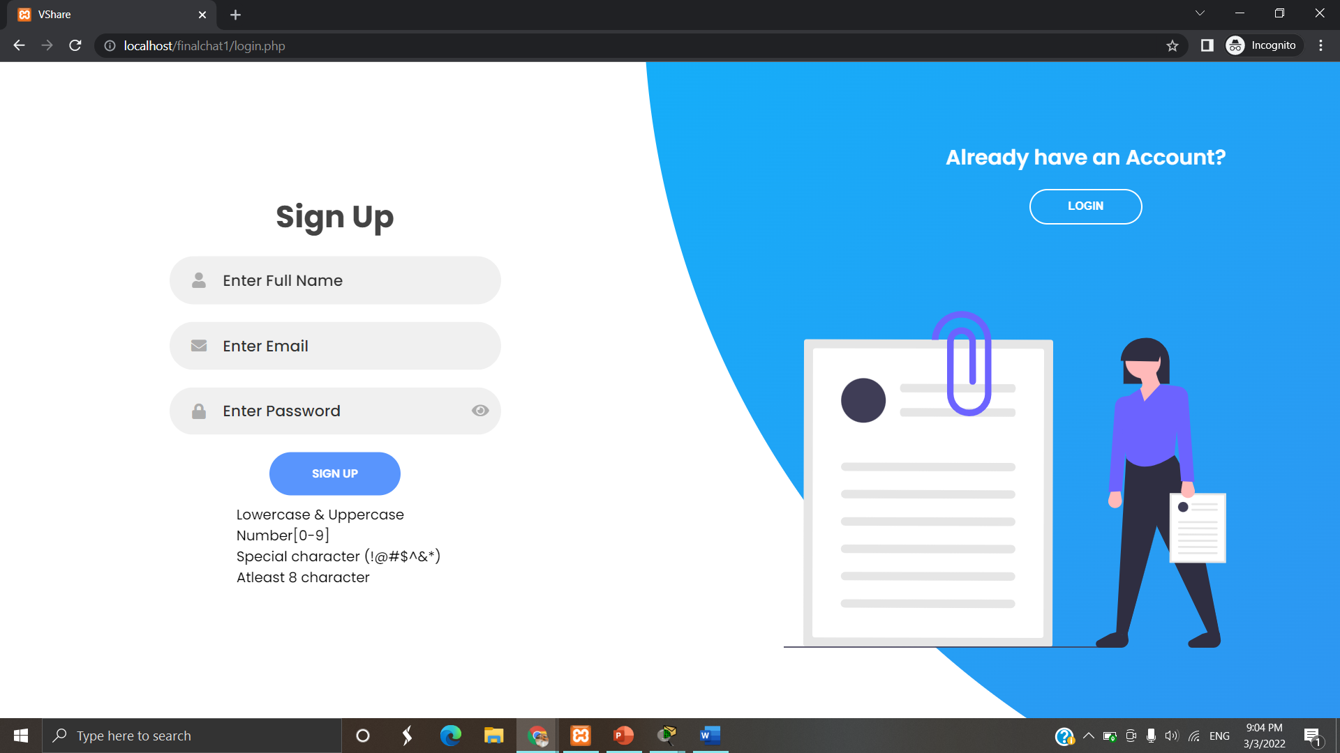

**Email-input Validation:**

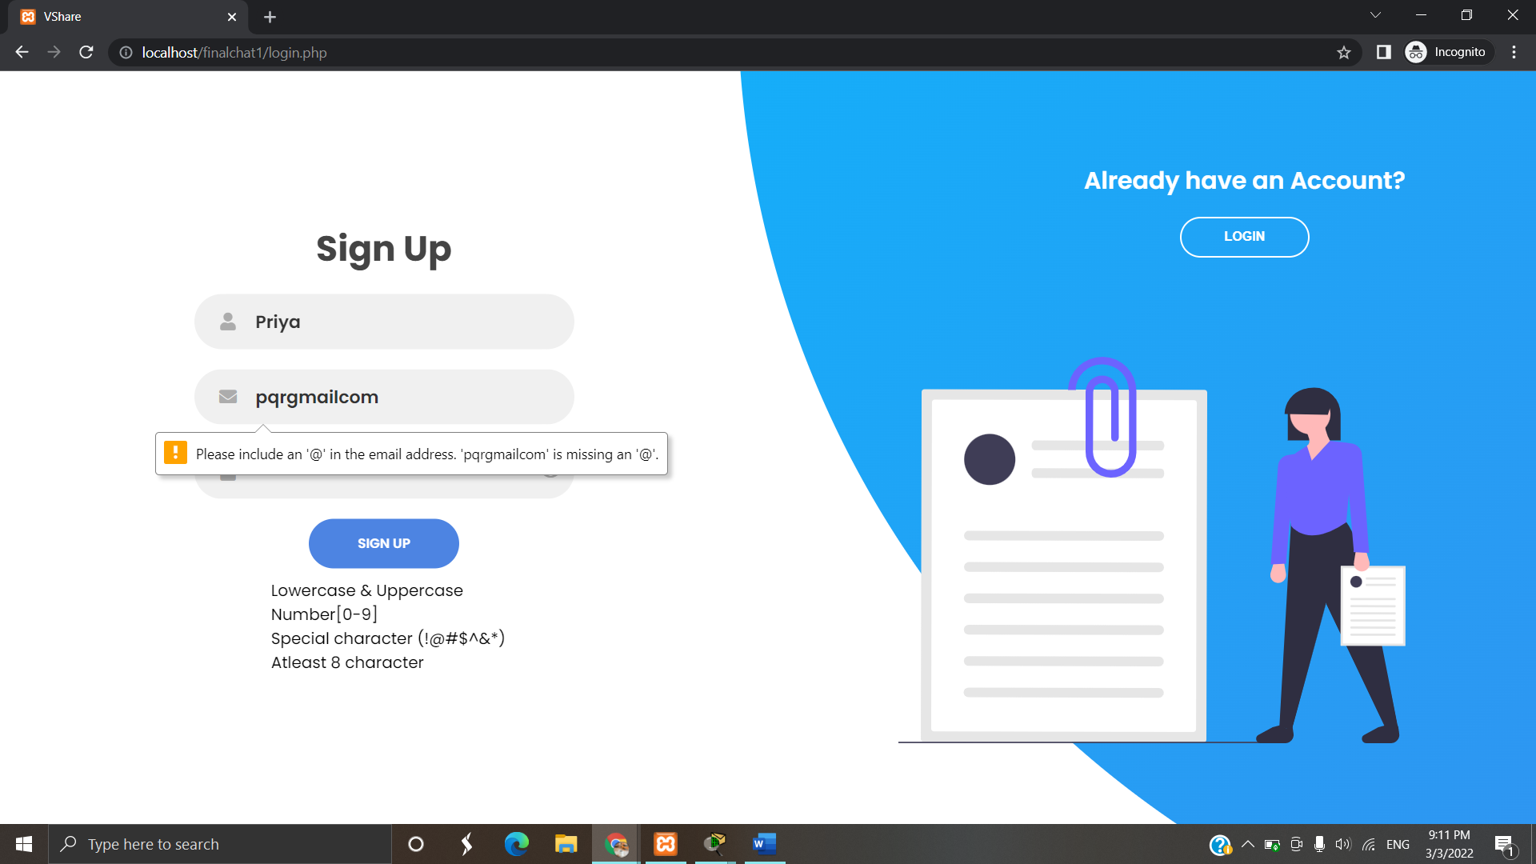

**On successful Registration:**

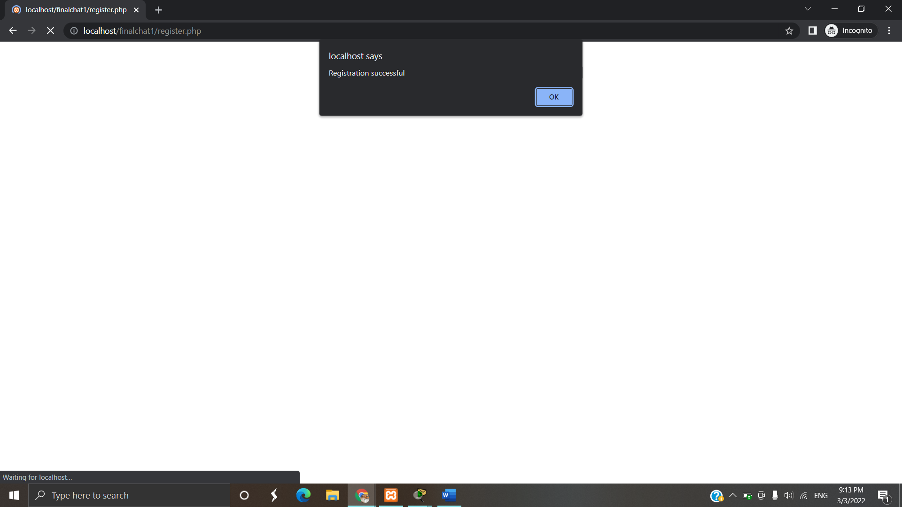

**Login Page:**

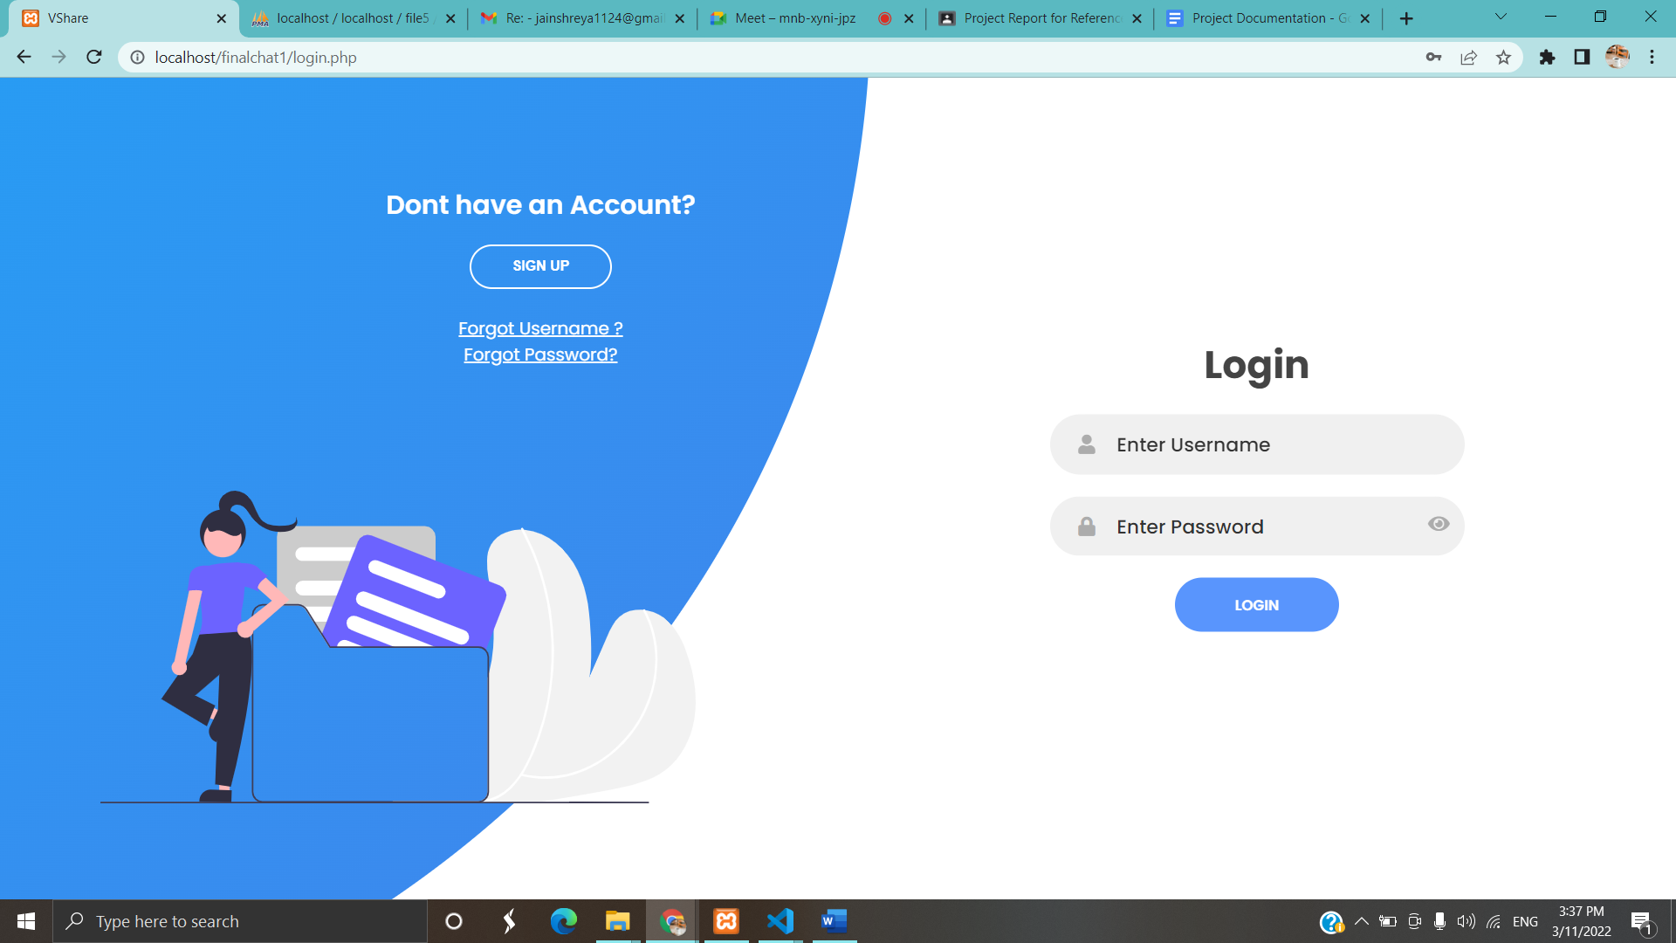

**On Entering Invalid Credentials:**

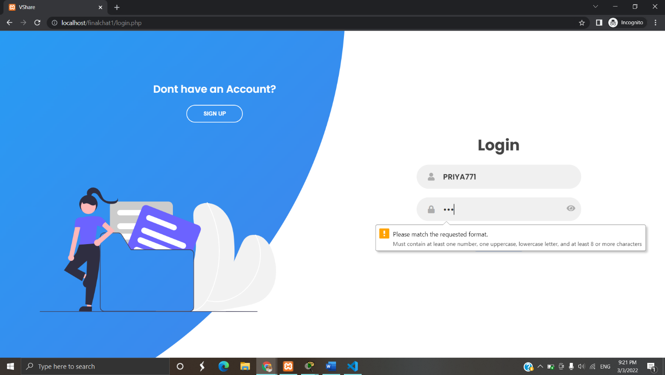

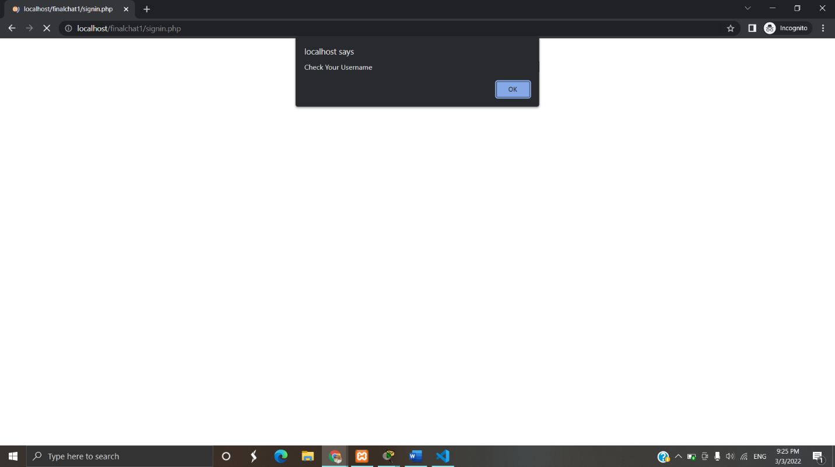

**After successful login user will be directed to this page:**

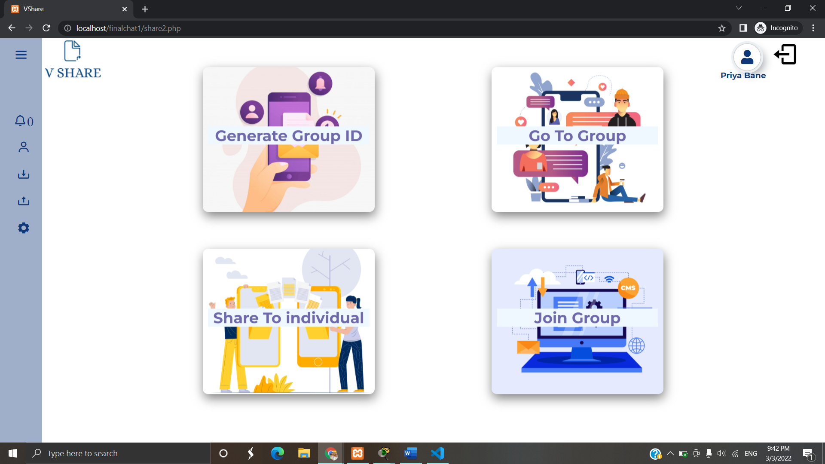

**On Generating GroupId:**

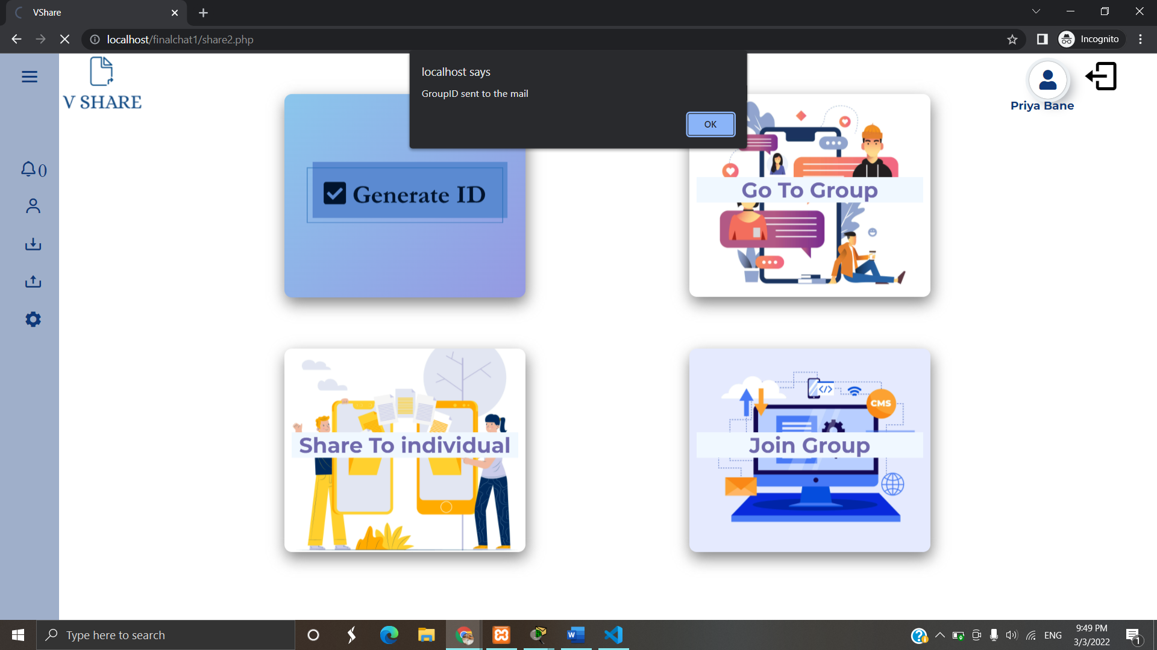

**Valid GroupId:**

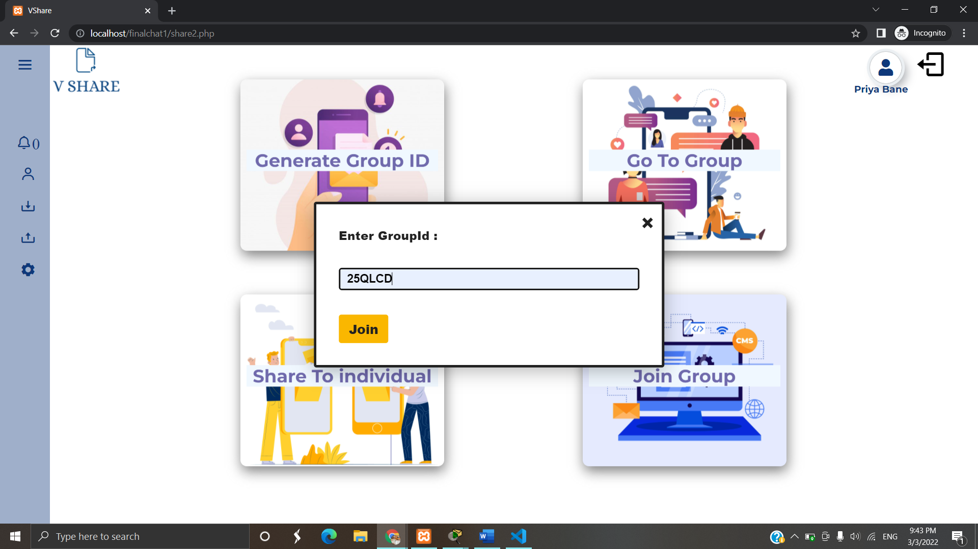

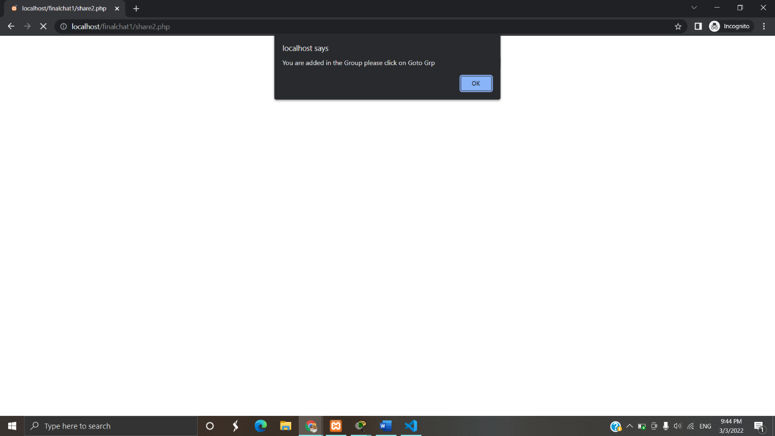

**Invalid GroupId:**

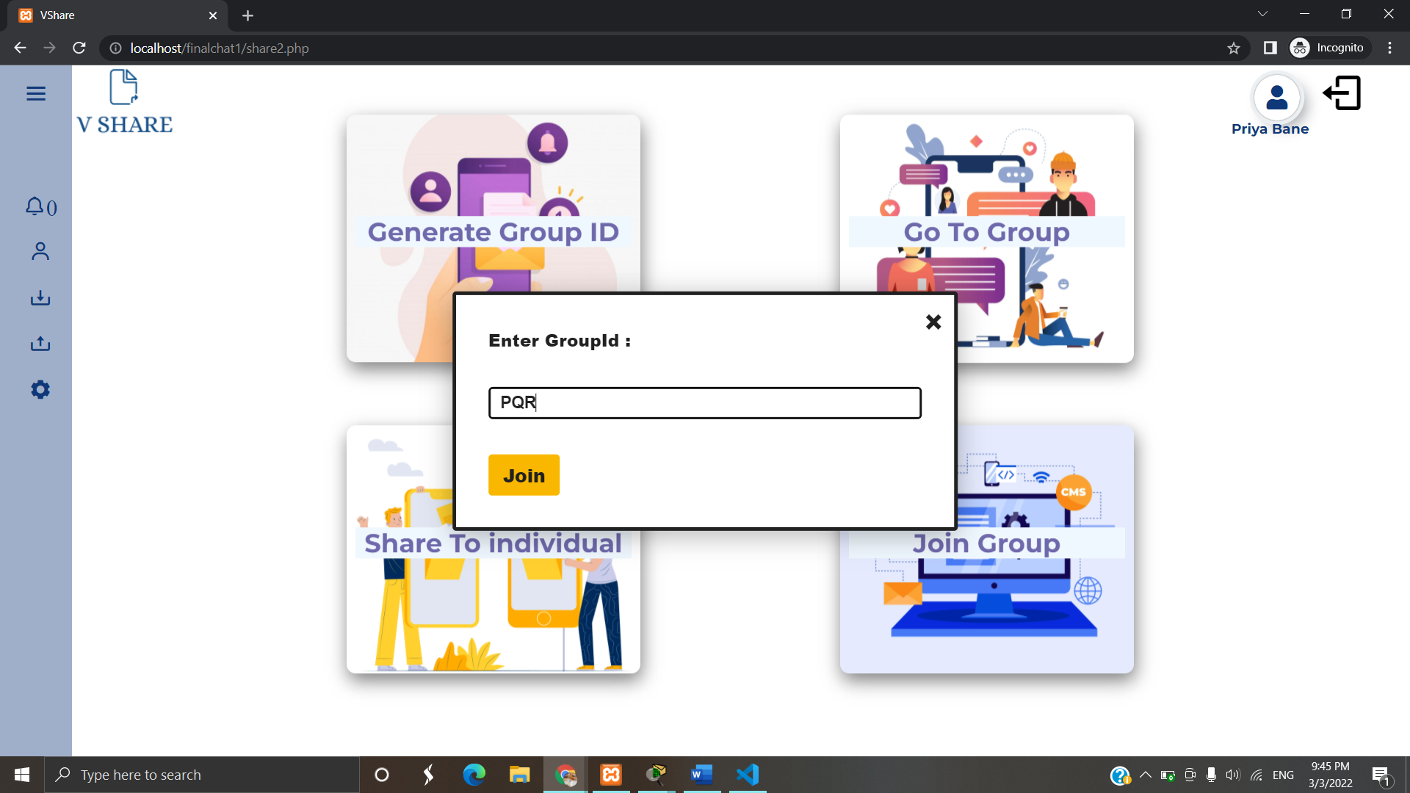

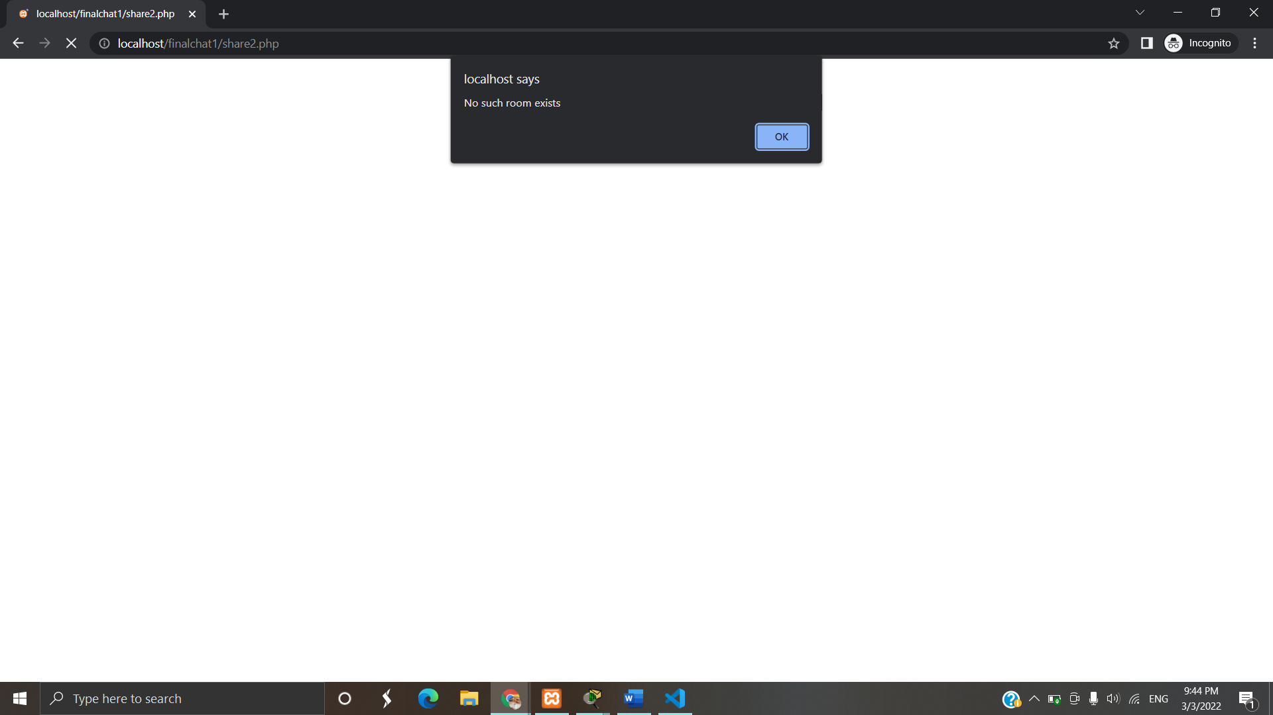

**List of Groups user-created and Joined:**

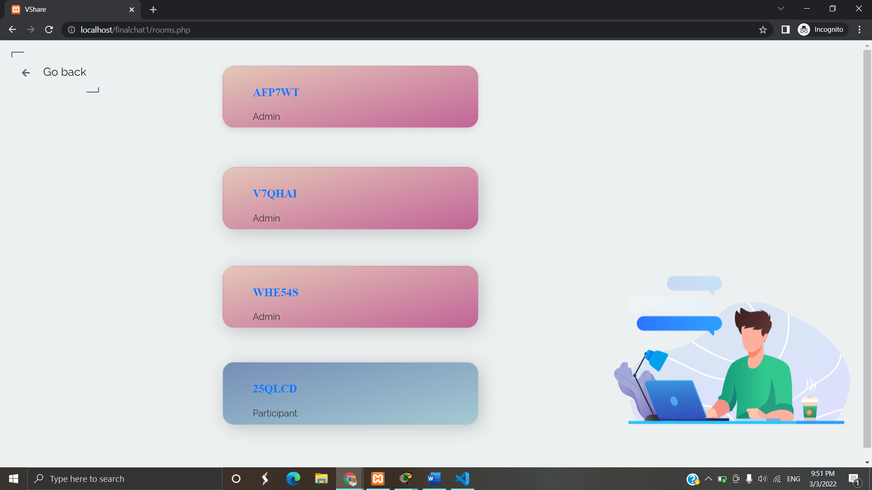

**User’s created Group**

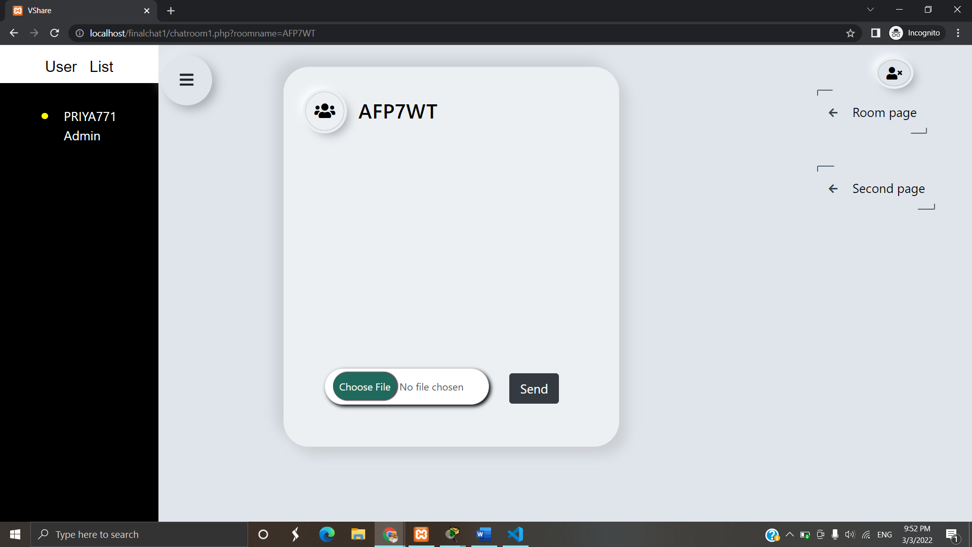

**Group which user joined:**

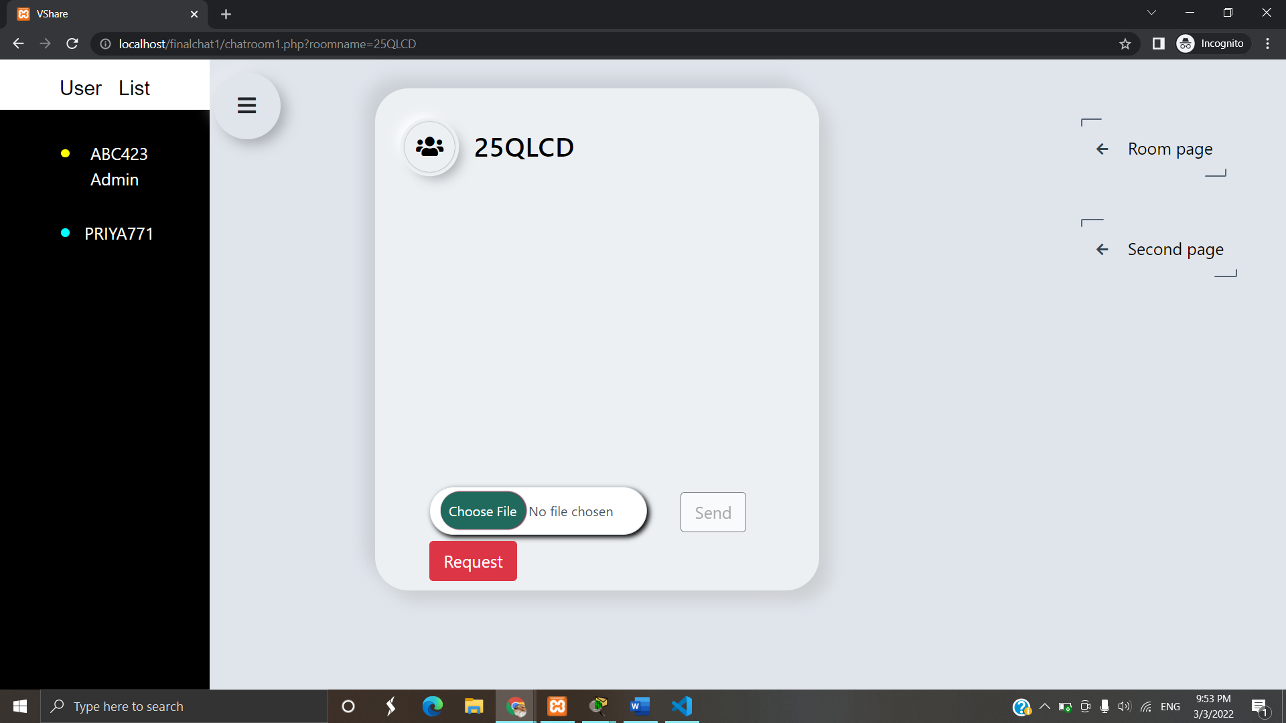

**Sending Request to admin to enable Send button:**

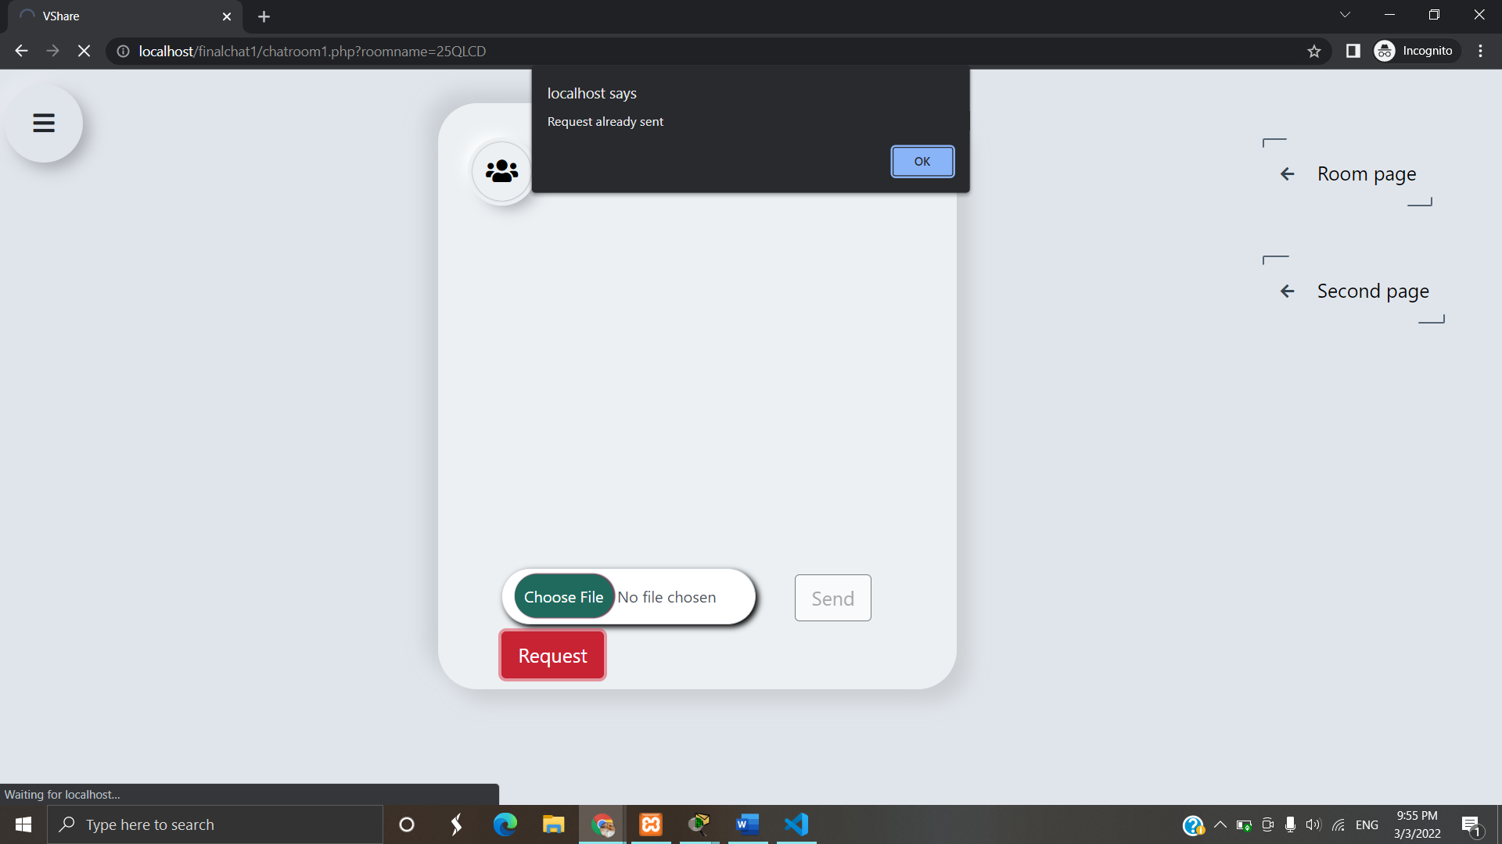

**When send button is enabled**

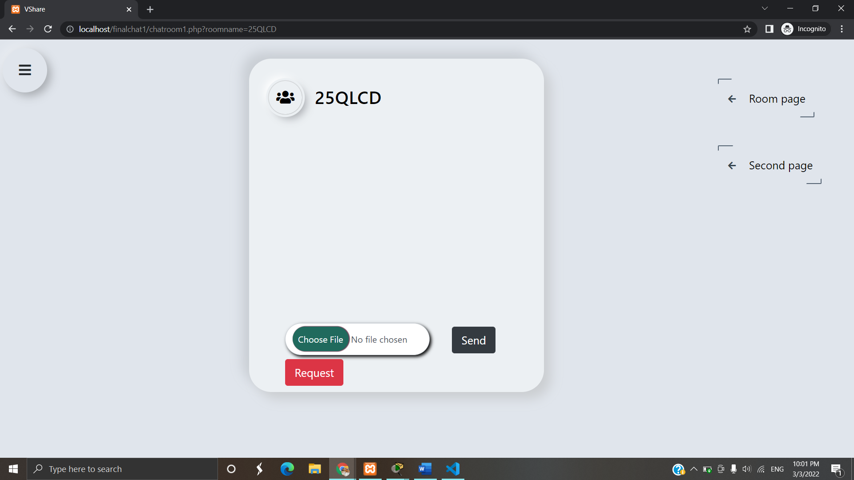

**To share files individually:**

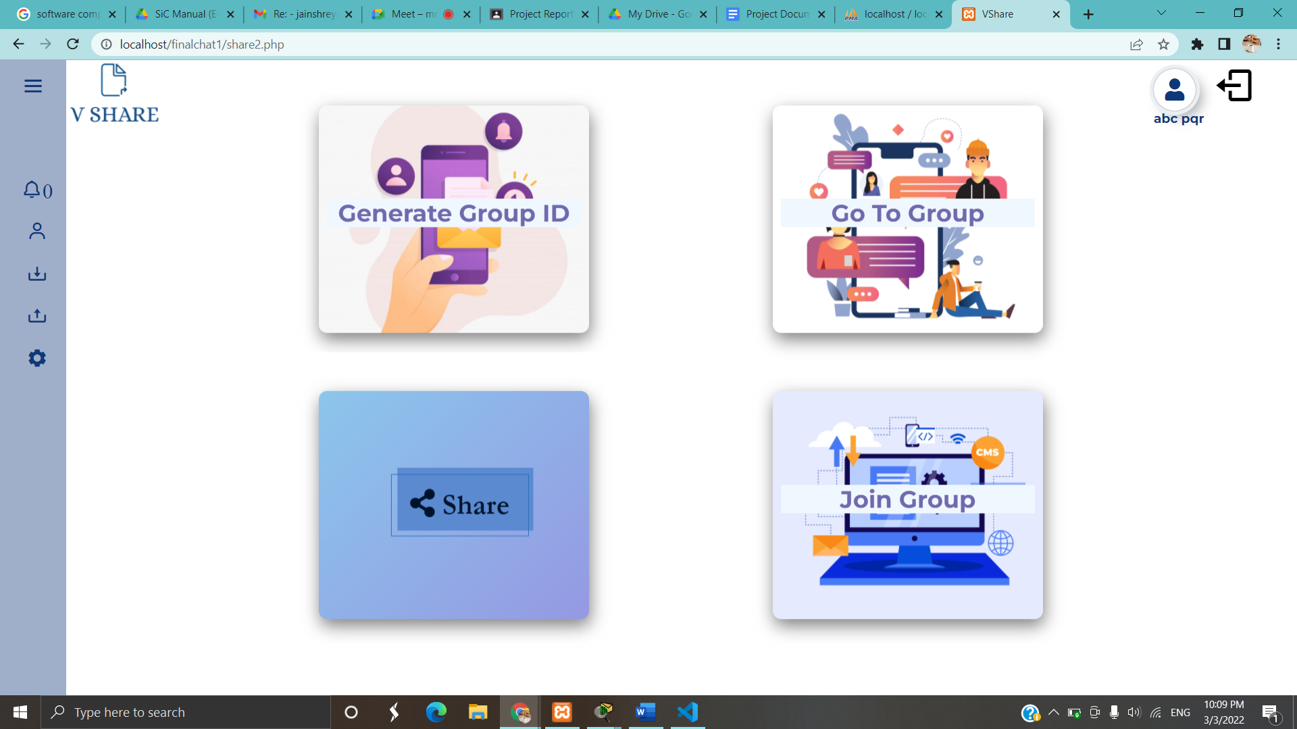

**Search Users**

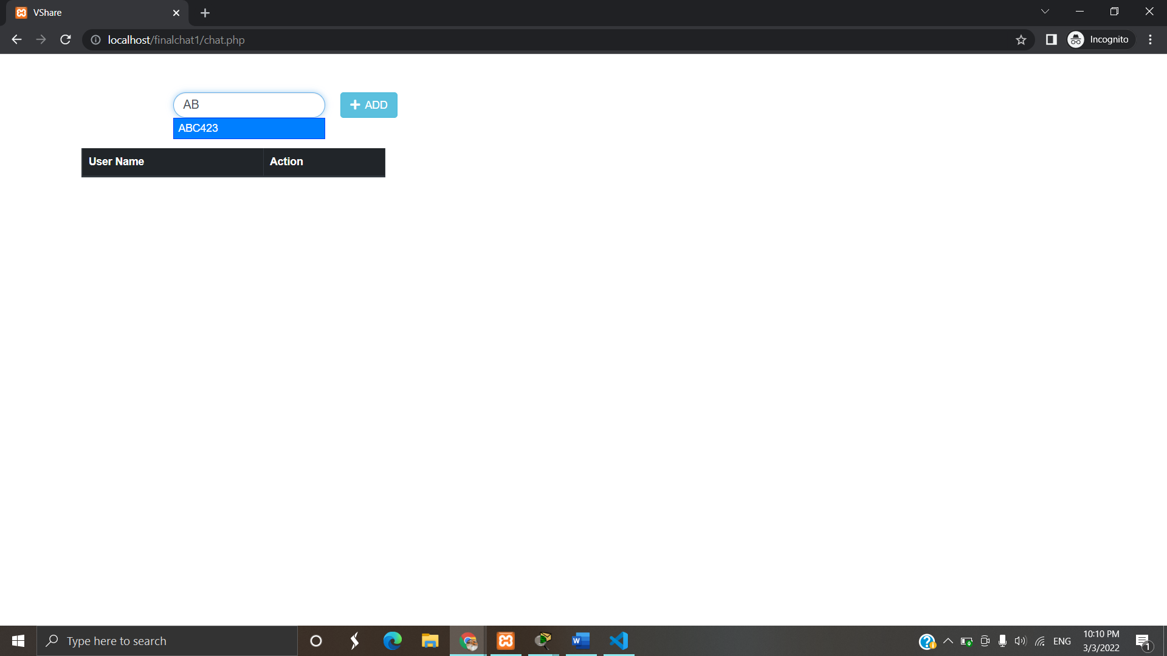

**Click on start chat to share file:**

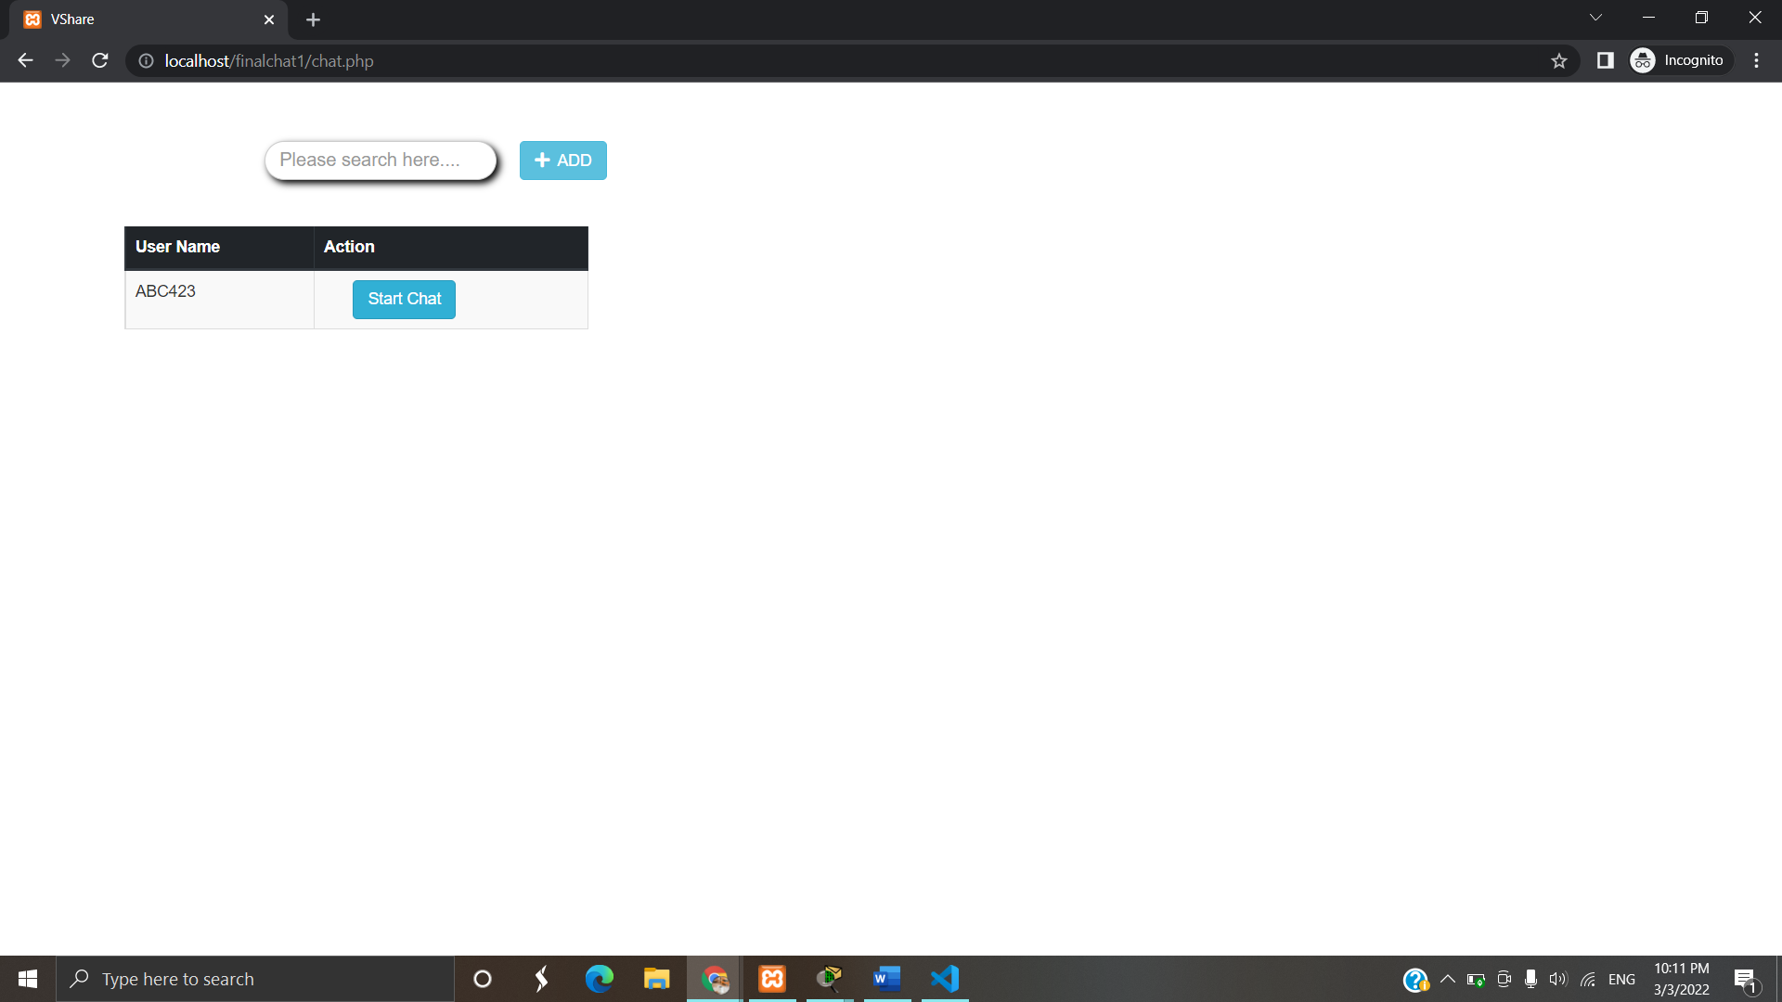

**On click of start chat button:**

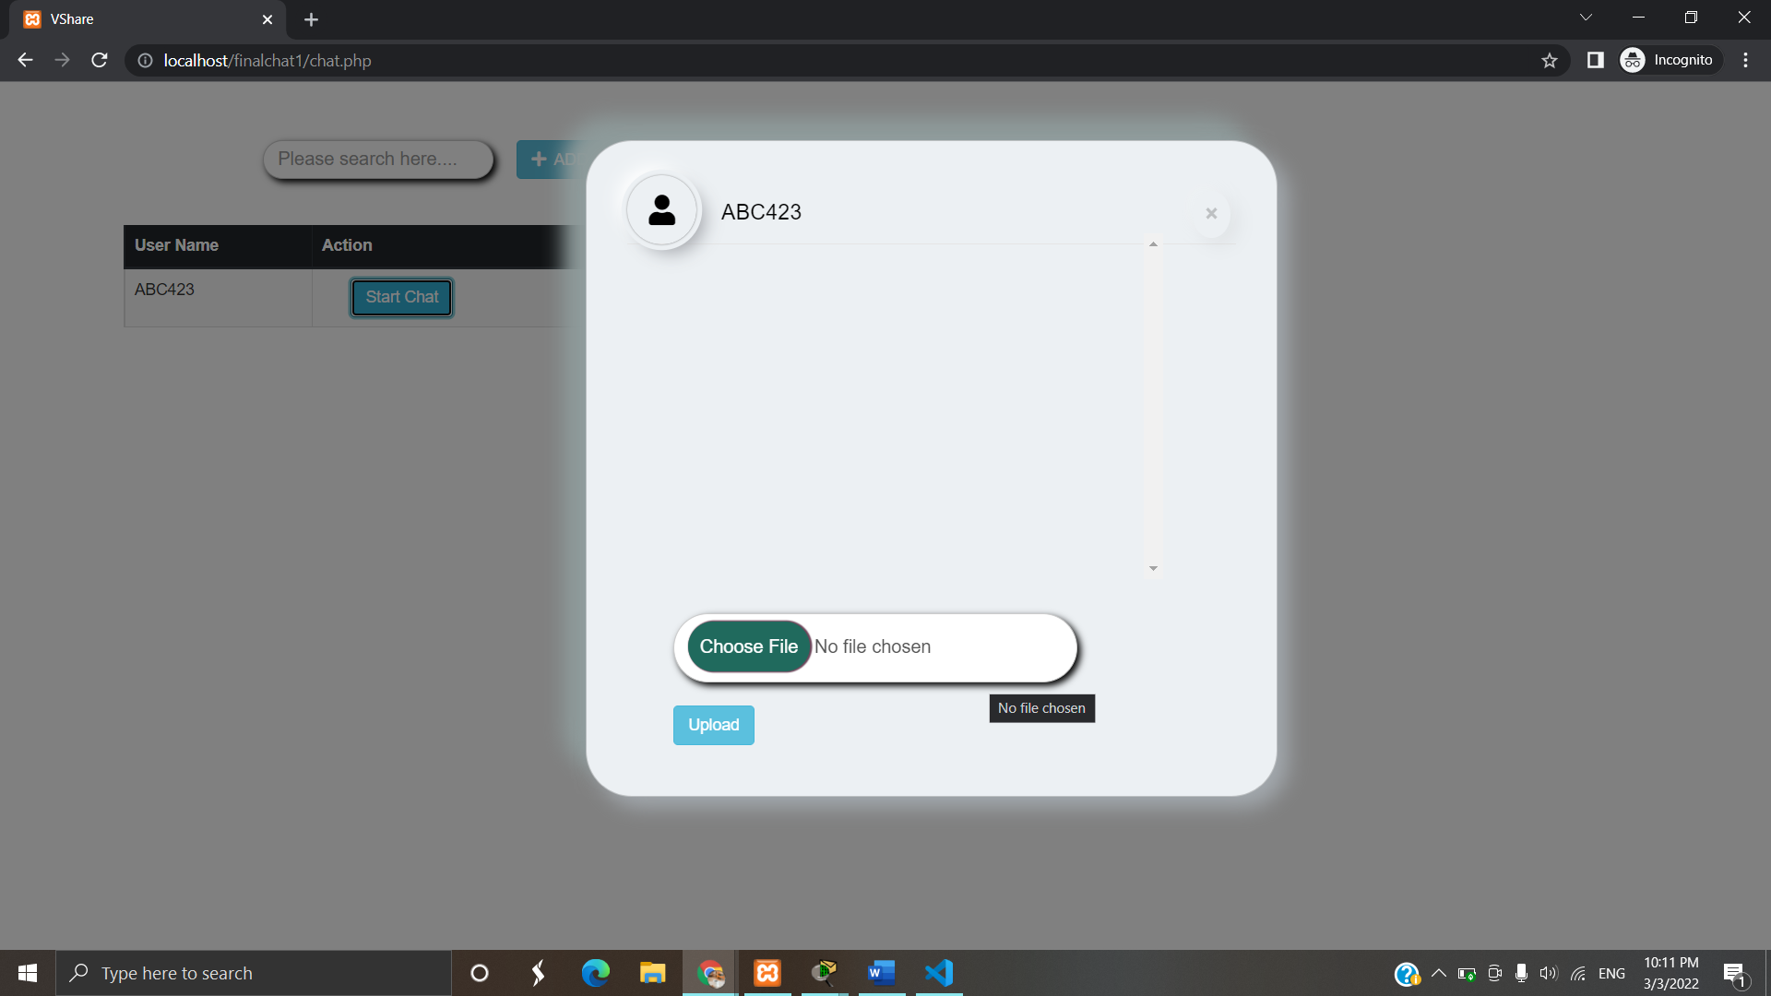

**Share File:**

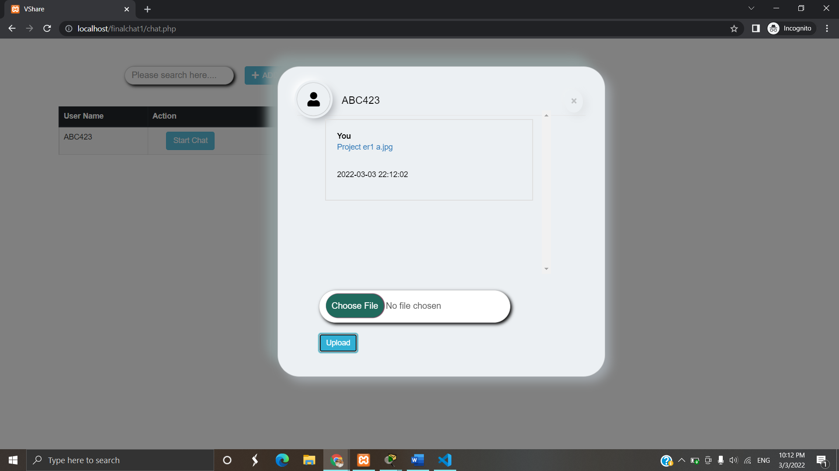

**To see Uploaded files:**

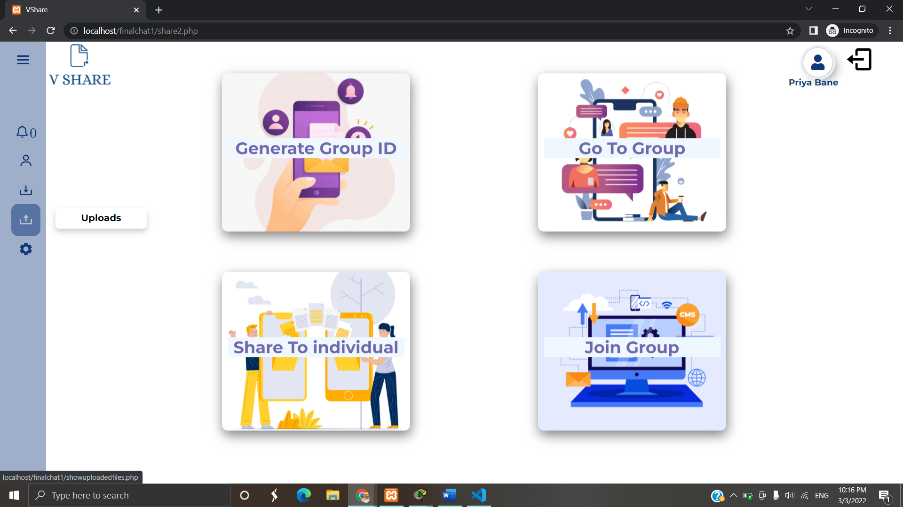

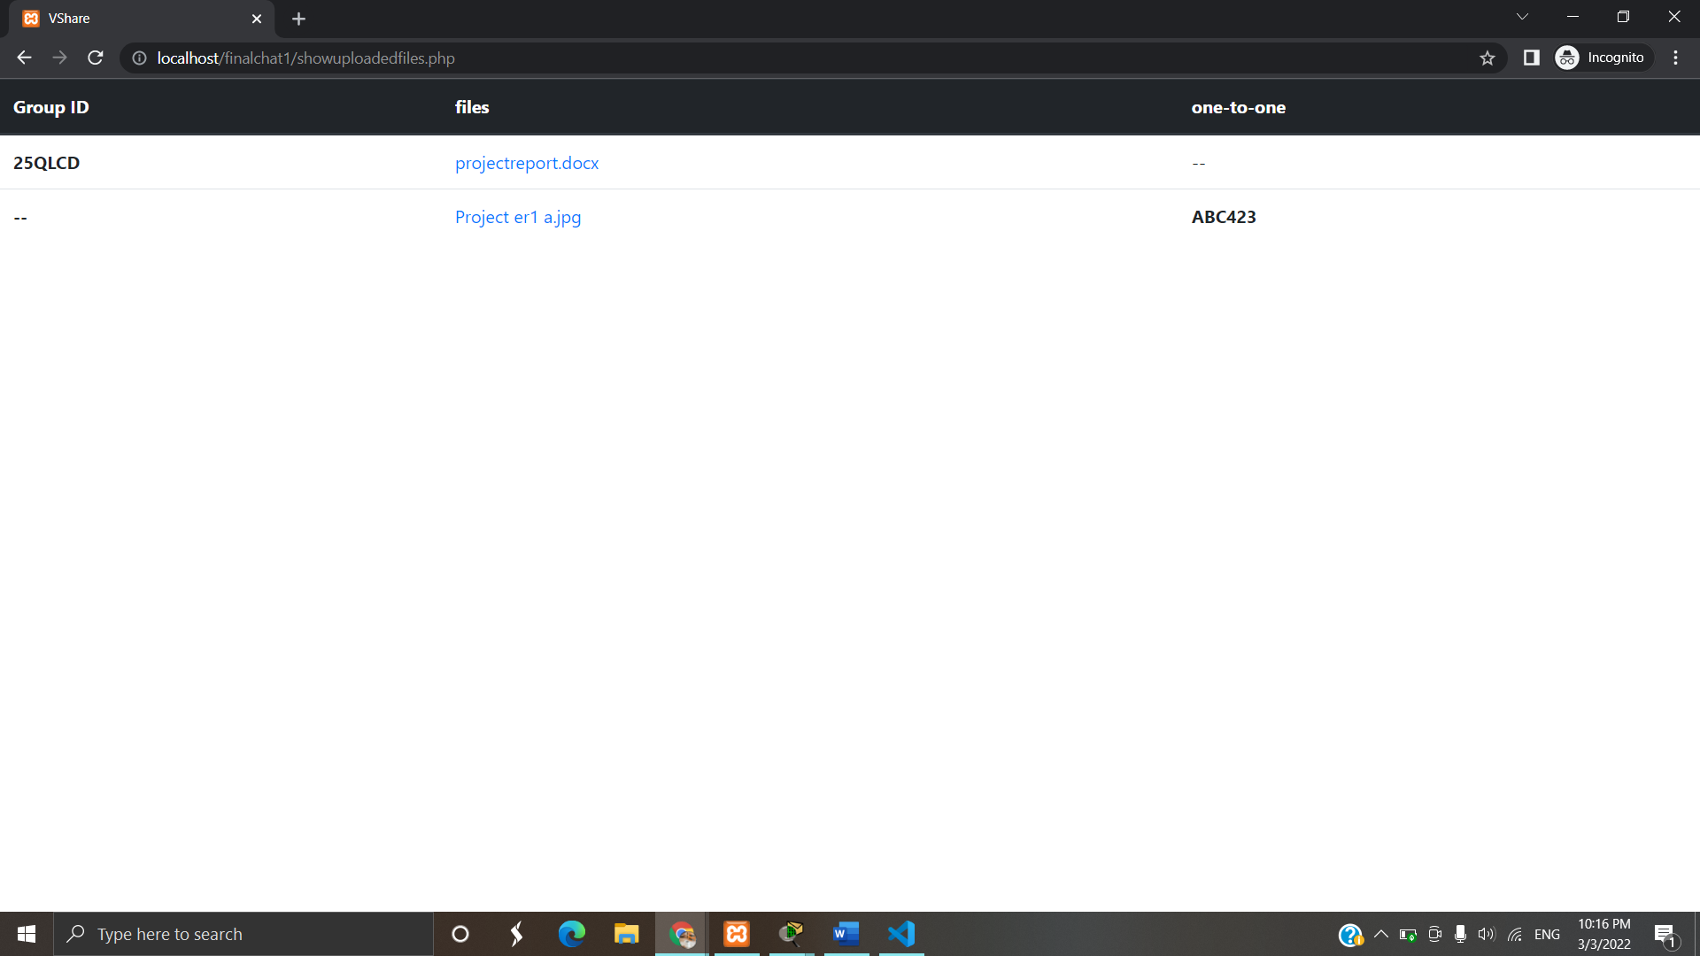

**To Download Files, Click on file name:**

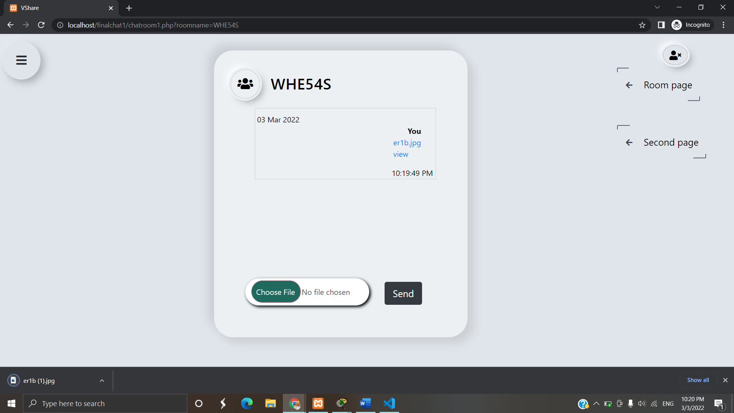

**To preview files, click on view:**

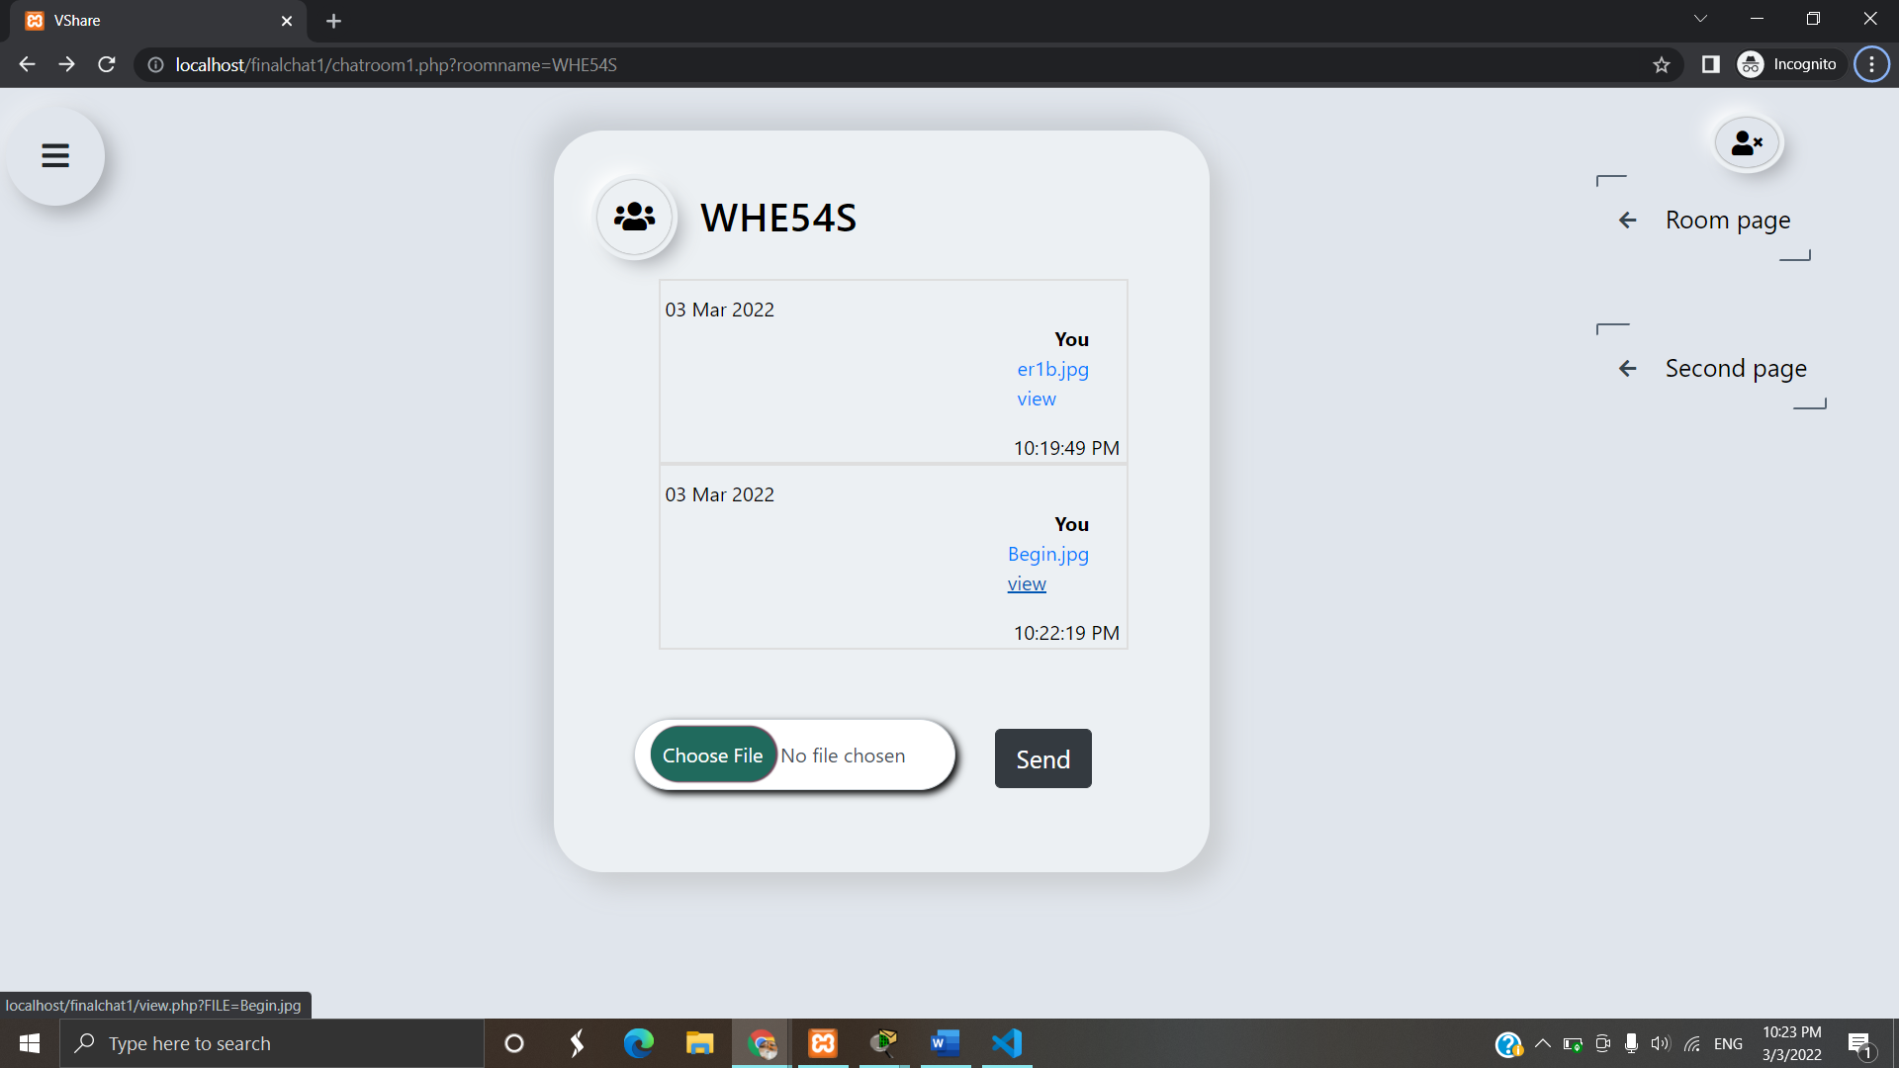

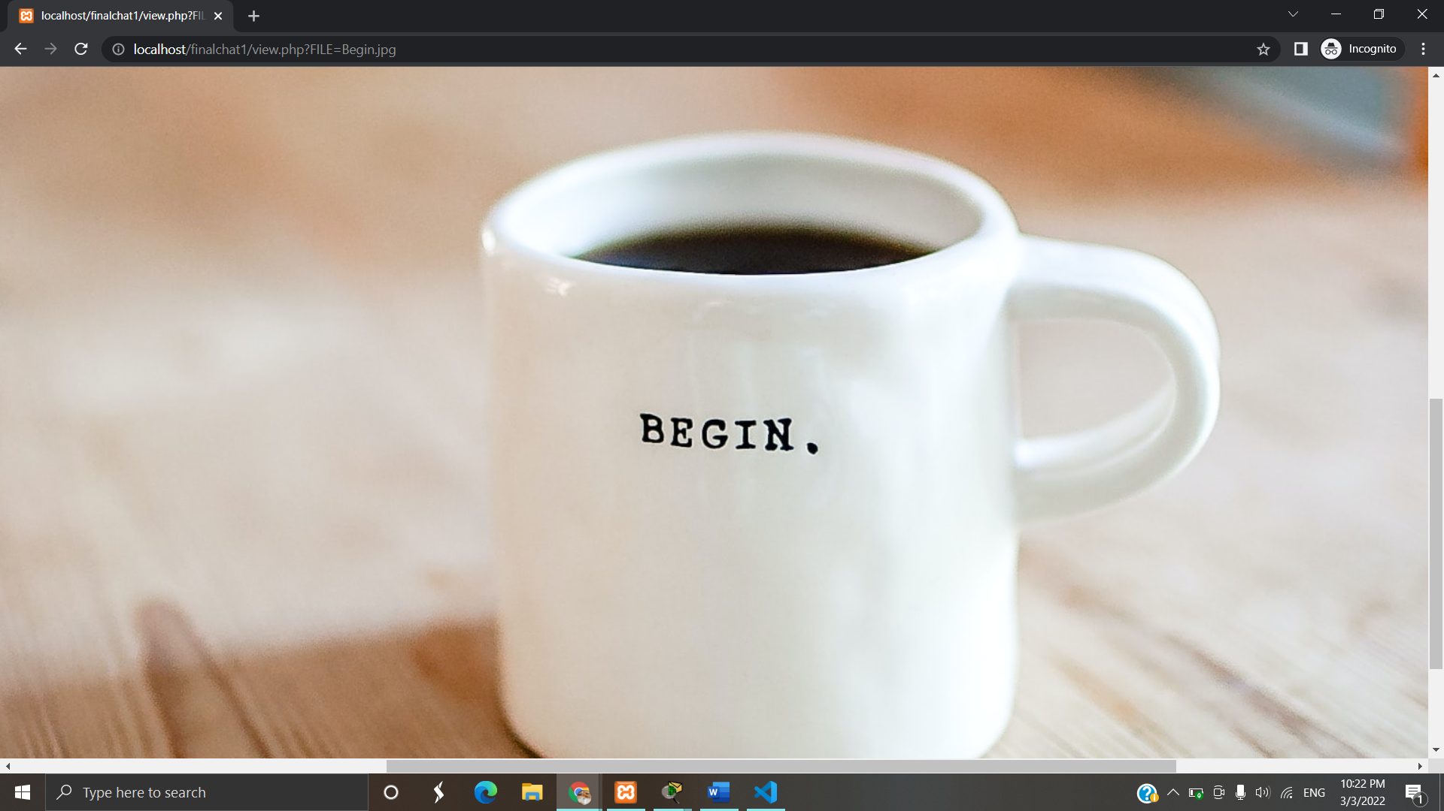

**To see Downloaded files:**

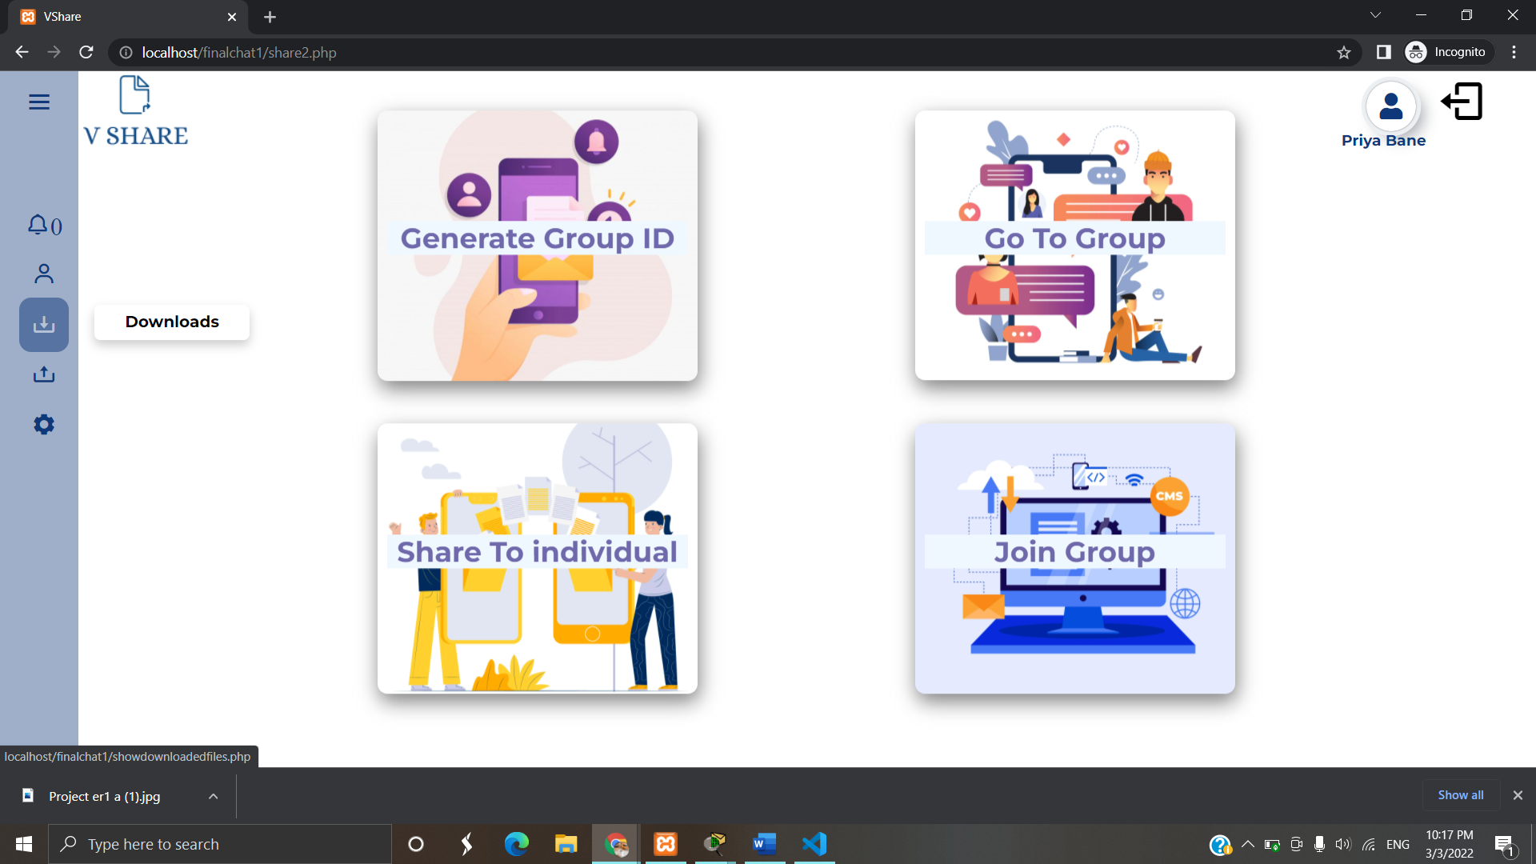

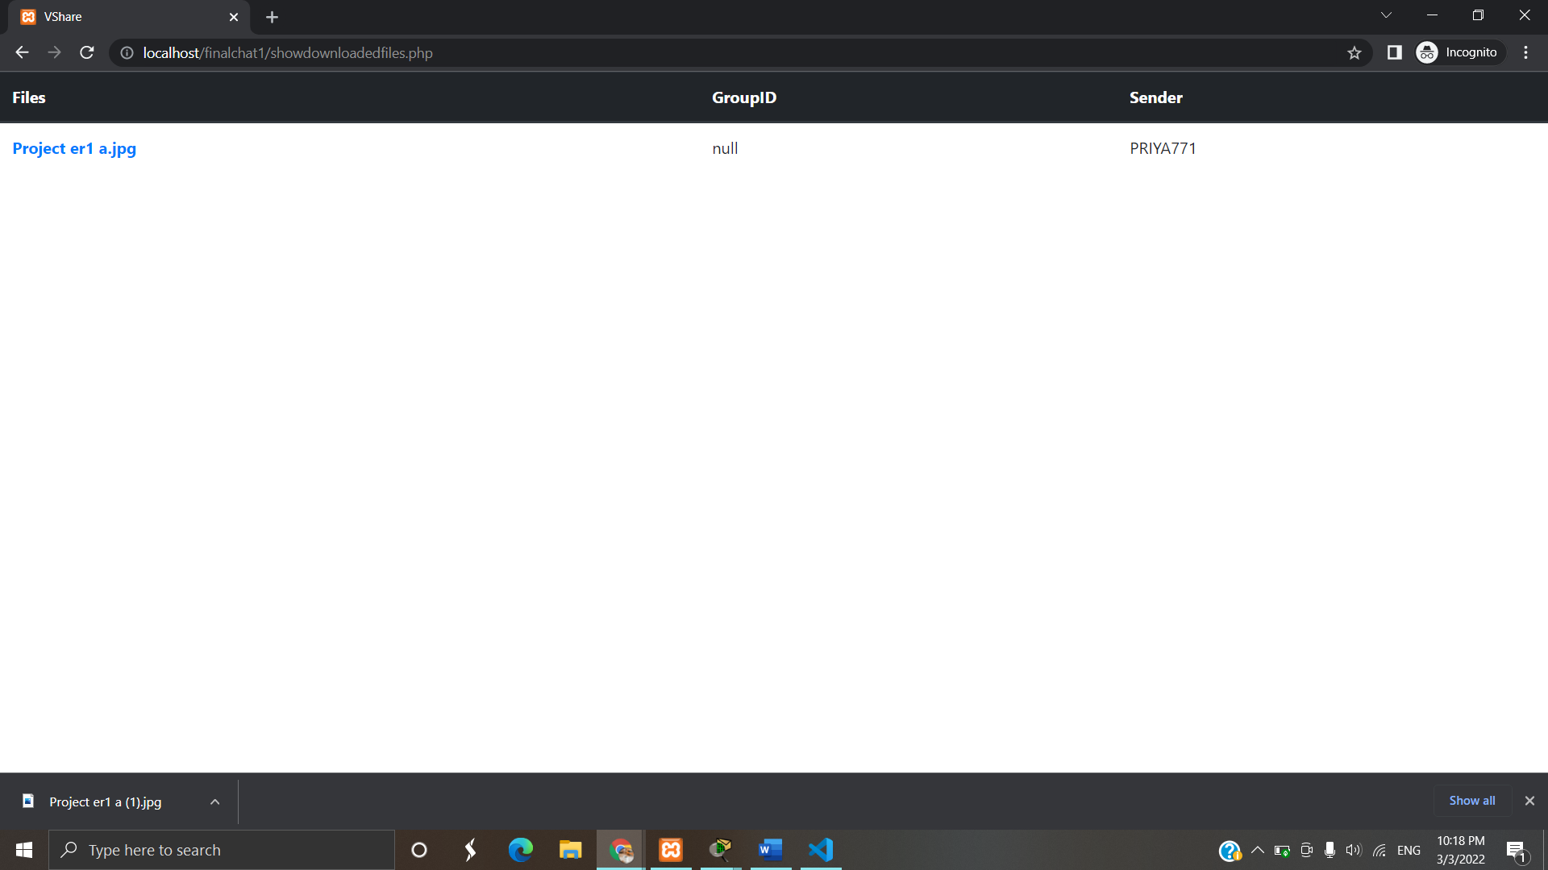

**Forgot Username and password:**

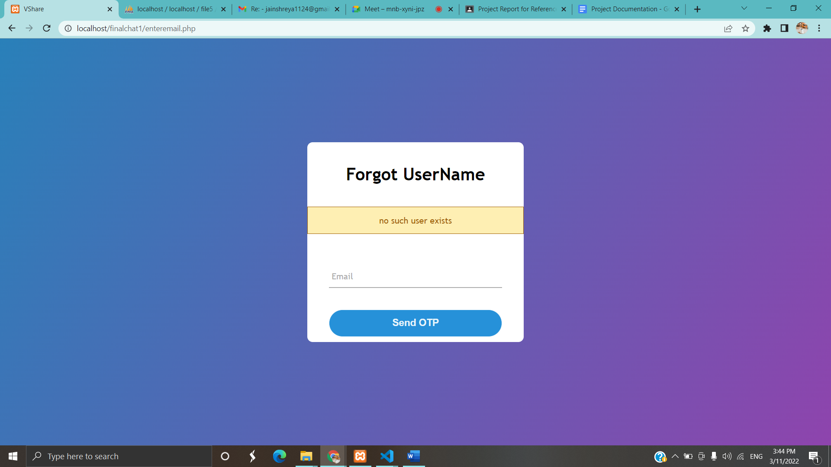

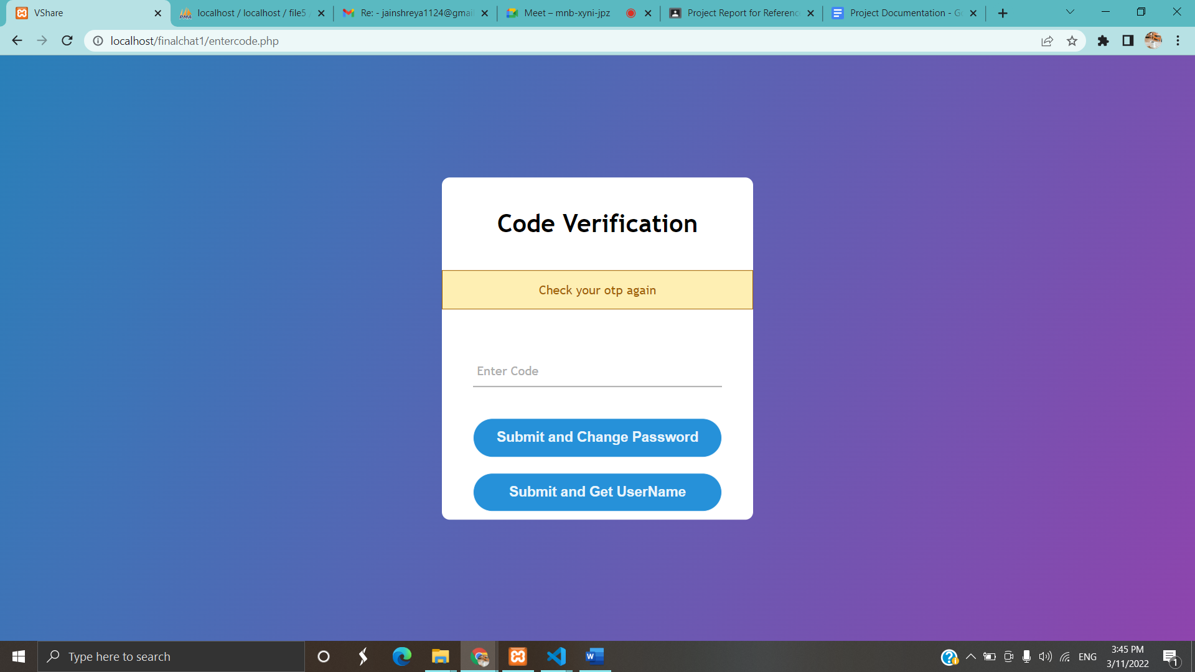

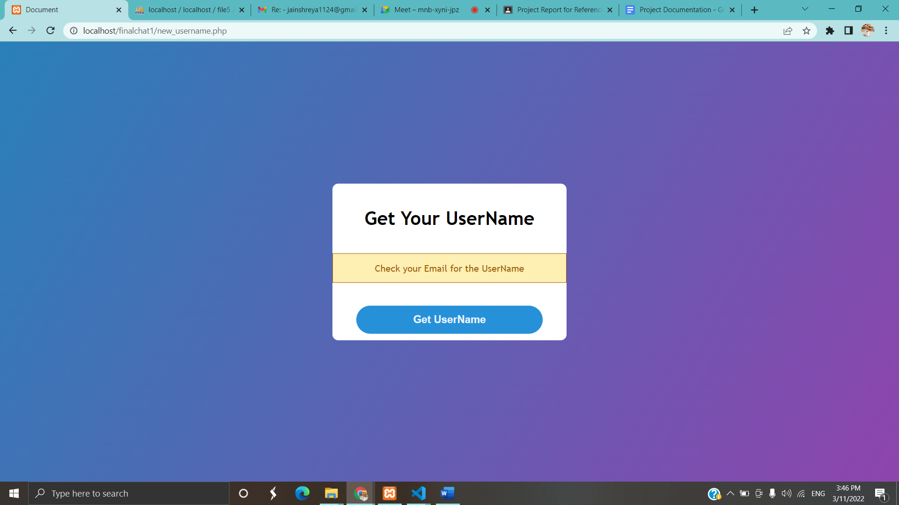

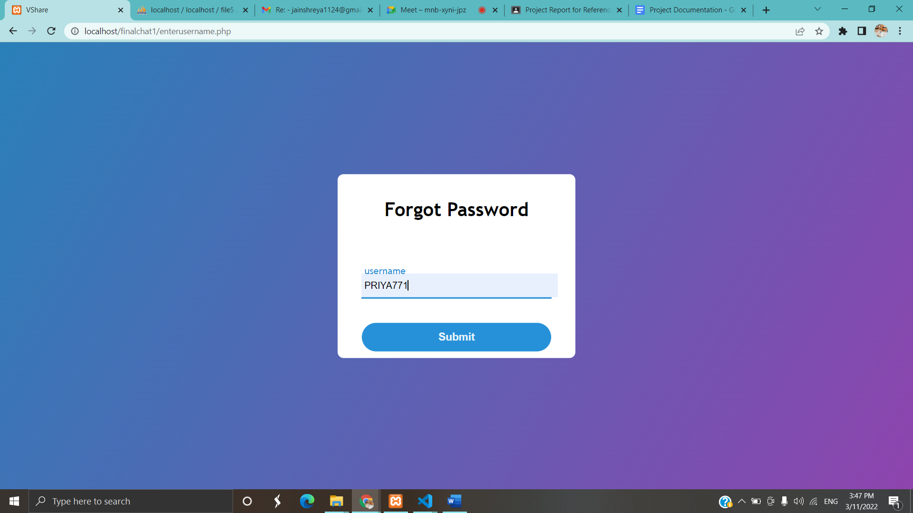

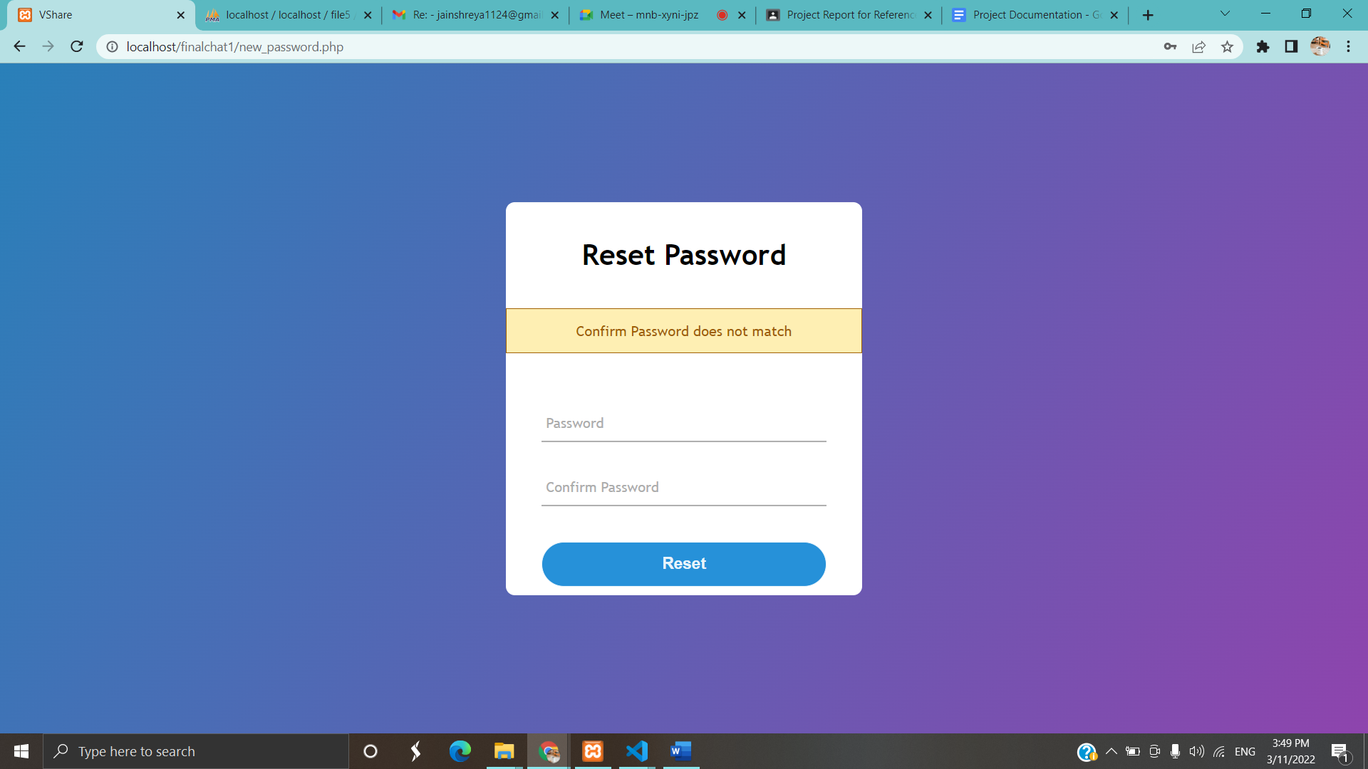

**Chapter 7**

**COST AND BENEFIT ANALYSIS**

The term “Cost Benefit Analysis” refers to how the software will prove to be beneficial than the existing system used in the organization implementing it.

Cost Benefit Analysis involves the balance of project expenditure and returns from its implementations. It must be noted that any software implementation involves initial investments and benefits are usually long term. System implementation time may vary for different organizations and it may also take some time for the employees of the different organizations to adjust with the system. A thorough analysis of the system was undertaken by keeping in the cost benefit ratio, details of which are as follows:

**COST EVALUATION**

* Software costs: The major software requirement for the system is Windows, VS code, XAMPP. Since both these softwares are freely available, so it didn’t cost us
* Development costs: No major expenses were involved in developing the application.

**Developer cost = (No. of days) *(Cost Per Developer) *2**

= 100*50*2

= 10,000

* Testing and Maintenance cost:

**Testing and Maintenance Cost = No. of hours * Charges per day * No. of Days**

No. of Hours = 2

Charges per day = 50

No. of Days = 20

Testing and Maintenance Cost = 2 * 50 * 20 = 2000 Rs.

Overall Cost = 12,000 Rs

**Chapter 8**

**8.1 CONCLUSION**

**8.1.1 SIGNIFICANCE OF THE SYSTEM:**

* This project helps in easy sharing of files.
* Files can be shared in a group or on one-to-one bases.
* It can be used by friend, family or small organizations.
* One can easily check for their downloaded files from within the application.
* One can also check for the uploaded files.
* Since the send is by default disabled for normal participants so sharing of unnecessary files can be prevented.
* User can have multiple roles

**8.2 LIMITATIONS OF THE SYSTEM:**

* Since the request for enabling the send button can only be accepted by the admin of the group, so the user needs to wait till the request is accepted.
* If the send button is disabled again for the particular user, then he needs to again send the request and wait for it to get accepted.
* Since the system doesn’t have the functionality of ‘Remember me’, so the user needs to login every-time he closes the browser.
* Since every message is sent through email so the users need to provide the correct email-id, otherwise he won’t be able to receive important notifications.

**8.3 FUTURE SCOPE OF THE PROJECT:**

* Improving the overall security of the project will allow to attract more users.
* Providing more features to the users.

**Annexure**

|  |  |
| --- | --- |
| **Abbreviation** | **Meaning** |
| 1. HTML | Hyper Text Markup Language |
| 2.CSS | Cascading Style Sheet |
| 3.PHP | Hypertext Preprocessor |
| 4. MYSQL | My Structured Query Language |
| 5. PERT | Program Evaluation Review Technique |
| 6.SQL | Structured Query Language |
| 7. DFD | Data flow Diagram |
| 8. ERD | Entity Relation Diagram |
| 9. VS code | Visual Studio code |
| 10.RAM | Random Access memory |
| 11. GB | Gigabyte |
| 12. UML | Unified Modelling Language |
| 13. UTF | Unicode Transformation Format |

**Bibliography**

1. <https://stackoverflow.com/>

2. <https://www.w3schools.com/>

3. [www.geeksforgeeks.com](http://www.geeksforgeeks.com)

4. [www.youtube.com](http://www.youtube.com)

5. <https://www.php.net/manual/en/index.php>